YEAR 7 MATHEMATICS
SMART-format mastery question bank
120 original practice questions mapped to all 40 item types in the 2026 Year 7 paper
A — LEARN THE FORMAT | B — INDEPENDENT MATCH | C — TRANSFER CHECK
Model, annotate and discuss. Students learn the wording and response conventions. | Use independently in lessons or homework. Demand closely matches the SMART item family. | Hold back for exit tickets or mini-tests. Includes new numbers or a small transfer twist.

Recommended use
• Teach with A, practise with B, and protect C until students work independently.
• Require students to show working even when the response is multiple choice.
• Discuss distractors: students should explain why each incorrect option is tempting.
• For homework, select 8-12 mixed B questions rather than giving an entire strand at once.
• A student is secure when they can solve at least two variants and explain the method.

Bank structure
Strand | Item families | Questions | Suggested use
Number | 14 | 42 | Lessons • homework • checks
Algebra | 4 | 12 | Lessons • homework • checks
Measurement | 6 | 18 | Lessons • homework • checks
Geometry | 7 | 21 | Lessons • homework • checks
Statistics & Probability | 6 | 18 | Lessons • homework • checks
Financial Maths | 3 | 9 | Lessons • homework • checks

QUESTION BANK MAP
Item families and teaching focus • 1 of 2
SMART | Strand | Skill focus | Practice codes
Q3 | Number | Multiply a four-digit number by a one-digit number | Q3A-C
Q5 | Number | Add decimals with unlike numbers of decimal places | Q5A-C
Q7 | Number | Multiply multiples of ten using place value | Q7A-C
Q9 | Number | Simplify a fraction using a common factor | Q9A-C
Q12 | Number | Round whole numbers to a stated place value | Q12A-C
Q18 | Number | Convert common fractions to percentages | Q18A-C
Q19 | Number | Apply order of operations, including powers | Q19A-C
Q21 | Number | Identify the value of a digit in a large number | Q21A-C
Q22 | Number | Find the difference between a value and a large target | Q22A-C
Q23 | Number | Calculate a percentage decrease from a large whole number | Q23A-C
Q24 | Number | Use division in a capacity context and round up | Q24A-C
Q28 | Number | Express a used amount as a fraction of a whole quantity | Q28A-C
Q29 | Number | Scale recipe quantities using proportional reasoning | Q29A-C
Q30 | Number | Use the lowest common multiple in repeating-time contexts | Q30A-C
Q1 | Algebra | Find an unknown in a two-step number sentence | Q1A-C
Q4 | Algebra | Continue a sequence with a constant difference | Q4A-C
Q17 | Algebra | Translate a purchasing context into an algebraic expression | Q17A-C
Q26 | Algebra | Use differences between two grouped equations to find one item | Q26A-C
Q6 | Measurement | Find a missing rectangle dimension from area | Q6A-C
Q14 | Measurement | Compare the volumes of cuboids | Q14A-C

QUESTION BANK MAP
Item families and teaching focus • 2 of 2
SMART | Strand | Skill focus | Practice codes
Q15 | Measurement | Calculate temperature changes across zero | Q15A-C
Q27 | Measurement | Read mass from a labelled scale | Q27A-C
Q31 | Measurement | Add a duration to a start time | Q31A-C
Q39 | Measurement | Multiply capacity and convert millilitres to litres | Q39A-C
Q2 | Geometry | Identify shapes containing more than one right angle | Q2A-C
Q8 | Geometry | Recognise rotational symmetry | Q8A-C
Q10 | Geometry | Apply quarter and three-quarter turns to compass directions | Q10A-C
Q11 | Geometry | Classify quadrilaterals from their properties | Q11A-C
Q25 | Geometry | Use angle sums and equal angles in isosceles triangles | Q25A-C
Q38 | Geometry | Use symmetry in an isosceles trapezium to find coordinates | Q38A-C
Q40 | Geometry | Apply a translation followed by reflection in the x-axis | Q40A-C
Q13 | Statistics & Probability | Read one category from a stacked bar chart | Q13A-C
Q16 | Statistics & Probability | Find the mode from a data table | Q16A-C
Q20 | Statistics & Probability | Use theoretical probability despite previous experimental results | Q20A-C
Q32 | Statistics & Probability | Infer a pictogram key from a known total | Q32A-C
Q36 | Statistics & Probability | Express a category probability as a percentage | Q36A-C
Q37 | Statistics & Probability | Find a missing value when the mean is known | Q37A-C
Q33 | Financial Maths | Substitute time into a cost formula with a fixed fee | Q33A-C
Q34 | Financial Maths | Find the greatest whole number of hours within a budget | Q34A-C
Q35 | Financial Maths | Adjust a cost formula when only the hourly rate is discounted | Q35A-C

NUMBER | Q3 QUESTION FAMILY
Multiply a four-digit number by a one-digit number • Response style: Write one numerical answer
A — LEARN THE FORMAT | B — INDEPENDENT MATCH | C — TRANSFER CHECK
Q3A  2 406 × 3 =  Answer: __________________ | Q3B  3 108 × 4 =  Answer: __________________ | Q3C  4 217 × 6 =  Answer: __________________
MASTERY HABIT | Estimate first so an unreasonable product is easy to reject.

NUMBER | Q5 QUESTION FAMILY
Add decimals with unlike numbers of decimal places • Response style: Choose one answer
A — LEARN THE FORMAT | B — INDEPENDENT MATCH | C — TRANSFER CHECK
Q5A  12.06 + 4.8 =  (A) 12.54  (B) 16.14  (C) 16.86  (D) 17.4 | Q5B  37.5 + 8.72 =  (A) 45.22  (B) 46.22  (C) 46.72  (D) 116.22 | Q5C  105.08 + 29.7 =  (A) 125.05  (B) 132.15  (C) 134.15  (D) 134.78
MASTERY HABIT | Write trailing zeros mentally so the decimal places stay aligned.

NUMBER | Q7 QUESTION FAMILY
Multiply multiples of ten using place value • Response style: Write one numerical answer
A — LEARN THE FORMAT | B — INDEPENDENT MATCH | C — TRANSFER CHECK
Q7A  40 × 70 =  Answer: __________________ | Q7B  60 × 300 =  Answer: __________________ | Q7C  250 × 80 =  Answer: __________________
MASTERY HABIT | Multiply the non-zero digits, then account for every place-value zero.

NUMBER | Q9 QUESTION FAMILY
Simplify a fraction using a common factor • Response style: Choose one answer
A — LEARN THE FORMAT | B — INDEPENDENT MATCH | C — TRANSFER CHECK
Q9A  What is 15/25 in its simplest form?  (A) 5/15  (B) 3/10  (C) 3/5  (D) 10/20 | Q9B  What is 24/36 in its simplest form?  (A) 4/9  (B) 2/3  (C) 6/8  (D) 12/18 | Q9C  What is 42/63 in its simplest form?  (A) 6/9  (B) 14/21  (C) 3/4  (D) 2/3
MASTERY HABIT | Divide the numerator and denominator by the same greatest common factor.

NUMBER | Q12 QUESTION FAMILY
Round whole numbers to a stated place value • Response style: Choose one answer
A — LEARN THE FORMAT | B — INDEPENDENT MATCH | C — TRANSFER CHECK
Q12A  What is 63 482 rounded to the nearest thousand?  (A) 63 000  (B) 63 400  (C) 63 500  (D) 64 000 | Q12B  What is 148 650 rounded to the nearest thousand?  (A) 148 000  (B) 148 600  (C) 148 700  (D) 149 000 | Q12C  What is 905 499 rounded to the nearest ten thousand?  (A) 900 000  (B) 905 000  (C) 910 000  (D) 1 000 000
MASTERY HABIT | Locate the rounding digit, then use only the digit immediately to its right.

NUMBER | Q18 QUESTION FAMILY
Convert common fractions to percentages • Response style: Choose one answer
A — LEARN THE FORMAT | B — INDEPENDENT MATCH | C — TRANSFER CHECK
Q18A  What is 3/4 as a percentage?  (A) 34%  (B) 43%  (C) 75%  (D) 80% | Q18B  What is 7/10 as a percentage?  (A) 17%  (B) 70%  (C) 71%  (D) 700% | Q18C  What is 9/20 as a percentage?  (A) 9%  (B) 20%  (C) 29%  (D) 45%
MASTERY HABIT | Rewrite the fraction with a denominator of 100 or convert it to a decimal first.

NUMBER | Q19 QUESTION FAMILY
Apply order of operations, including powers • Response style: Choose one answer
A — LEARN THE FORMAT | B — INDEPENDENT MATCH | C — TRANSFER CHECK
Q19A  5² - 3 × 4 =  (A) 8  (B) 13  (C) 40  (D) 88 | Q19B  48 ÷ 6 + 2³ =  (A) 10  (B) 11  (C) 16  (D) 64 | Q19C  3 × (7 - 2) + 4² =  (A) 19  (B) 23  (C) 27  (D) 31
MASTERY HABIT | Calculate powers first, then multiplication or division, then addition or subtraction.

NUMBER | Q21 QUESTION FAMILY
Identify the value of a digit in a large number • Response style: Choose one answer
A — LEARN THE FORMAT | B — INDEPENDENT MATCH | C — TRANSFER CHECK
Q21A  What is the value of the digit 8 in 684 250?  (A) 8 000  (B) 80 000  (C) 800 000  (D) 800 | Q21B  What is the value of the digit 5 in 3 507 900?  (A) 5 000  (B) 50 000  (C) 500 000  (D) 5 000 000 | Q21C  What is the value of the digit 4 in 9 047 316?  (A) 4 000  (B) 40 000  (C) 400 000  (D) 4 000 000
MASTERY HABIT | Name the place before deciding the value: digit × place value.

NUMBER | Q22 QUESTION FAMILY
Find the difference between a value and a large target • Response style: Write one numerical answer
A — LEARN THE FORMAT | B — INDEPENDENT MATCH | C — TRANSFER CHECK
Q22A  A video has 742 650 views. How many more views are needed to reach 1 000 000?  Answer: __________________ | Q22B  A fundraiser has collected $1 386 750. How much more is needed to reach $2 000 000?  Answer: __________________ | Q22C  A game has 6 745 900 downloads. How many more are needed to reach 10 000 000?  Answer: __________________
MASTERY HABIT | Subtract the current amount from the target and check by adding the difference back.

NUMBER | Q23 QUESTION FAMILY
Calculate a percentage decrease from a large whole number • Response style: Choose one answer
A — LEARN THE FORMAT | B — INDEPENDENT MATCH | C — TRANSFER CHECK
Q23A  A second app has 10% fewer downloads than an app with 348 000 downloads. How many downloads does it have?  (A) 34 800  (B) 310 000  (C) 313 200  (D) 382 800 | Q23B  A store sold 20% fewer tickets than last year's 625 000. How many tickets did it sell?  (A) 125 000  (B) 500 000  (C) 605 000  (D) 750 000 | Q23C  A channel received 15% fewer views than last month's 480 000. How many views did it receive?  (A) 72 000  (B) 400 000  (C) 412 000  (D) 408 000
MASTERY HABIT | Find the decrease, then subtract it from the original amount.

NUMBER | Q24 QUESTION FAMILY
Use division in a capacity context and round up • Response style: Choose one answer
A — LEARN THE FORMAT | B — INDEPENDENT MATCH | C — TRANSFER CHECK
Q24A  There are 196 students. Each bus seats 32 students. How many buses are needed?  (A) 5 buses  (B) 6 buses  (C) 7 buses  (D) 8 buses | Q24B  There are 275 guests. Each table seats 24 guests. How many tables are needed?  (A) 11 tables  (B) 12 tables  (C) 13 tables  (D) 14 tables | Q24C  A library packs 1 045 books into boxes holding 48 books each. How many boxes are needed?  (A) 20 boxes  (B) 21 boxes  (C) 21.8 boxes  (D) 22 boxes
MASTERY HABIT | A remainder means one more bus, table or container is still needed.

NUMBER | Q28 QUESTION FAMILY
Express a used amount as a fraction of a whole quantity • Response style: Choose one answer
A — LEARN THE FORMAT | B — INDEPENDENT MATCH | C — TRANSFER CHECK
Q28A  A recipe uses 200 mL from an 800 mL bottle. What fraction of the bottle is used?  (A) 1/4  (B) 1/3  (C) 2/5  (D) 3/4 | Q28B  A recipe uses 350 g from a 1 kg bag. What fraction of the bag is used?  (A) 3/10  (B) 7/10  (C) 7/20  (D) 13/20 | Q28C  A drink uses 450 mL from a 1.5 L bottle. What fraction of the bottle is used?  (A) 3/5  (B) 3/10  (C) 9/20  (D) 45/150
MASTERY HABIT | Convert both amounts to the same unit before forming and simplifying the fraction.

NUMBER | Q29 QUESTION FAMILY
Scale recipe quantities using proportional reasoning • Response style: Write one numerical answer
A — LEARN THE FORMAT | B — INDEPENDENT MATCH | C — TRANSFER CHECK
Q29A  A recipe for 12 buns uses 180 g of flour. How much flour is needed for 30 buns?  Answer: __________________ | Q29B  A recipe for 8 smoothies uses 600 mL of milk. How much milk is needed for 20 smoothies?  Answer: __________________ | Q29C  A recipe for 15 bars uses 240 g of oats. How many grams are needed for 40 bars?  Answer: __________________
MASTERY HABIT | Find the amount for one item or use a scale factor that applies to both quantities.

NUMBER | Q30 QUESTION FAMILY
Use the lowest common multiple in repeating-time contexts • Response style: Choose one answer
A — LEARN THE FORMAT | B — INDEPENDENT MATCH | C — TRANSFER CHECK
Q30A  Two lights flash every 6 minutes and every 8 minutes. They flash together at 10:00. When do they next flash together?  (A) 10:12  (B) 10:14  (C) 10:24  (D) 10:48 | Q30B  Two bells ring every 9 minutes and every 12 minutes. They ring together at 1:15 pm. When do they next ring together?  (A) 1:36 pm  (B) 1:51 pm  (C) 2:03 pm  (D) 2:15 pm | Q30C  Two signals sound every 14 minutes and every 21 minutes. They sound together at 9:30 am. When do they next sound together?  (A) 9:51 am  (B) 9:58 am  (C) 10:02 am  (D) 10:12 am
MASTERY HABIT | List multiples until the first common time interval appears.

ALGEBRA | Q1 QUESTION FAMILY
Find an unknown in a two-step number sentence • Response style: Write the missing number
A — LEARN THE FORMAT | B — INDEPENDENT MATCH | C — TRANSFER CHECK
Q1A  Write a number in the box to make this true: 4 × □ + 3 = 19  Answer: __________________ | Q1B  Write a number in the box to make this true: 5 × □ - 7 = 28  Answer: __________________ | Q1C  Write a number in the box to make this true: 6 × □ + 11 = 59  Answer: __________________
MASTERY HABIT | Undo addition or subtraction first, then undo multiplication.

ALGEBRA | Q4 QUESTION FAMILY
Continue a sequence with a constant difference • Response style: Write the next term
A — LEARN THE FORMAT | B — INDEPENDENT MATCH | C — TRANSFER CHECK
Q4A  This sequence goes up in equal steps. Complete it: 45 250, 46 750, 48 250, ______  Answer: __________________ | Q4B  This sequence goes up in equal steps. Complete it: 302 600, 307 600, 312 600, ______  Answer: __________________ | Q4C  This sequence goes down in equal steps. Complete it: 875 400, 869 900, 864 400, ______  Answer: __________________
MASTERY HABIT | Subtract adjacent terms to expose the repeated step.

ALGEBRA | Q17 QUESTION FAMILY
Translate a purchasing context into an algebraic expression • Response style: Choose one expression
A — LEARN THE FORMAT | B — INDEPENDENT MATCH | C — TRANSFER CHECK
Q17A  A sports pass costs p dollars and a drink costs d dollars. Maia buys 4 passes and 1 drink. Which expression is the total cost?  (A) 4 + p + d  (B) 4p × d  (C) 4(p + d)  (D) 4p + d | Q17B  A music lesson costs l dollars. Equipment hire is a one-off $12. Which expression is the cost of 3 lessons and the equipment?  (A) 3 + l + 12  (B) 3l + 12  (C) 3(l + 12)  (D) 36l | Q17C  An adult ticket costs a dollars and a child ticket costs c dollars. Which expression is the cost of 2 adult and 3 child tickets?  (A) 5ac  (B) 2(a + 3c)  (C) 2a + 3c  (D) 2a × 3c
MASTERY HABIT | Attach the coefficient to the repeated item; add one-off costs separately.

ALGEBRA | Q26 QUESTION FAMILY
Use differences between two grouped equations to find one item • Response style: Write one numerical answer
A — LEARN THE FORMAT | B — INDEPENDENT MATCH | C — TRANSFER CHECK
Q26A  Five large bags and two small bags have a mass of 39 kg. Three large bags and two small bags have a mass of 27 kg. What is the mass of one large bag?  Answer: __________________ | Q26B  Four large boxes and three small boxes have a mass of 41 kg. Two large boxes and three small boxes have a mass of 25 kg. What is the mass of one large box?  Answer: __________________ | Q26C  Six full crates and two empty crates have a mass of 58 kg. Three full crates and two empty crates have a mass of 34 kg. What is the mass of one full crate?  Answer: __________________
MASTERY HABIT | Subtract the two situations so the repeated unknown cancels.

MEASUREMENT | Q6 QUESTION FAMILY
Find a missing rectangle dimension from area • Response style: Choose one answer
A — LEARN THE FORMAT | B — INDEPENDENT MATCH | C — TRANSFER CHECK
Q6A  A rectangle has an area of 35 cm² and a width of 5 cm. What is its length?  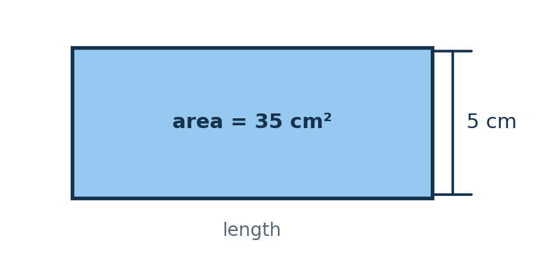  (A) 5 cm  (B) 7 cm  (C) 30 cm  (D) 175 cm | Q6B  A rectangle has an area of 72 m² and a width of 8 m. What is its length?  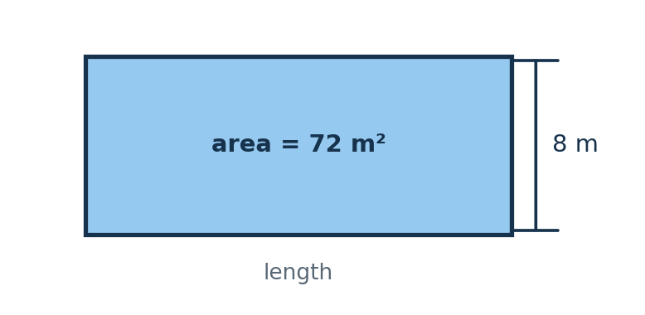  (A) 8 m  (B) 8.5 m  (C) 9 m  (D) 64 m | Q6C  A rectangle has an area of 117 cm² and a width of 9 cm. What is its length?  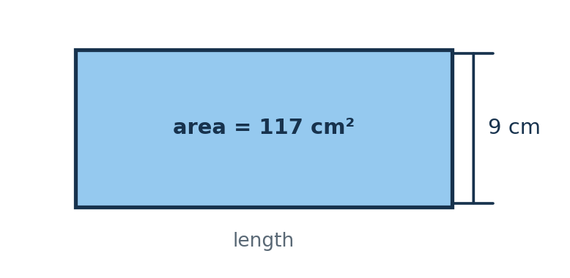  (A) 9 cm  (B) 12 cm  (C) 108 cm  (D) 13 cm
MASTERY HABIT | Use length = area ÷ width and keep the units consistent.

MEASUREMENT | Q14 QUESTION FAMILY
Compare the volumes of cuboids • Response style: Choose one diagram
A — LEARN THE FORMAT | B — INDEPENDENT MATCH | C — TRANSFER CHECK
Q14A  Each cuboid is made from unit cubes. Which cuboid has the largest volume?  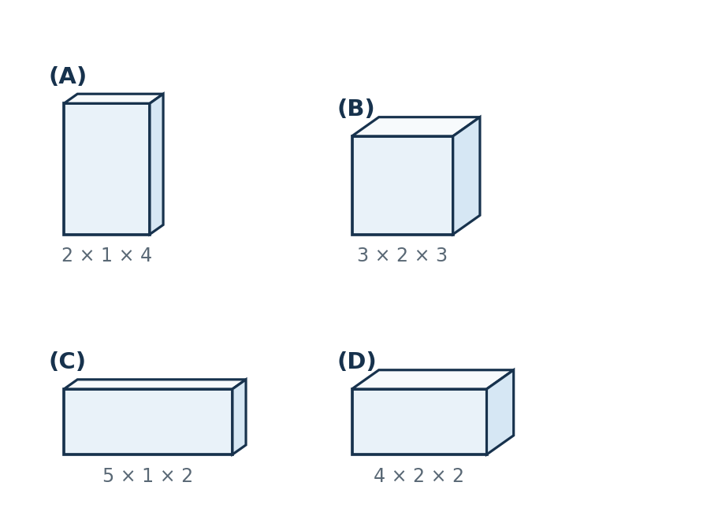  (A) Cuboid A  (B) Cuboid B  (C) Cuboid C  (D) Cuboid D | Q14B  Each cuboid is made from unit cubes. Which cuboid has the largest volume?  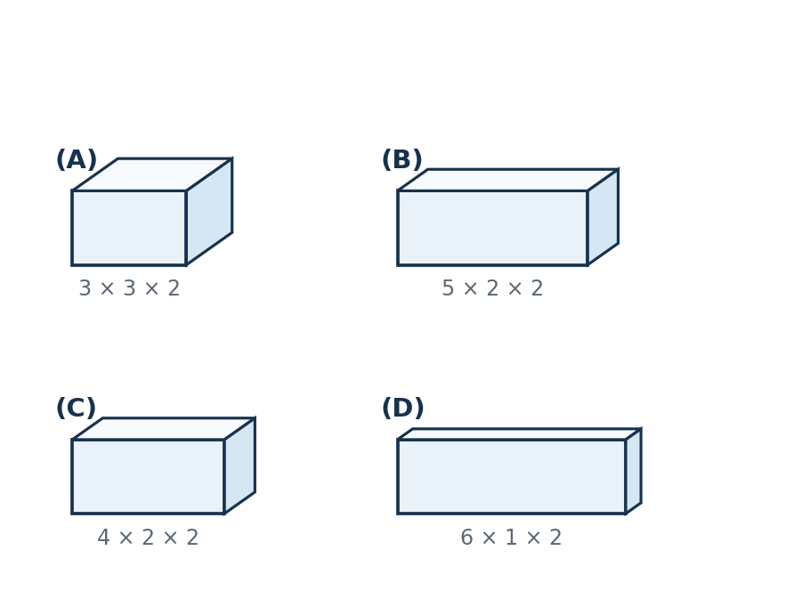  (A) Cuboid A  (B) Cuboid B  (C) Cuboid C  (D) Cuboid D | Q14C  Each cuboid is made from unit cubes. Which cuboid has the largest volume?  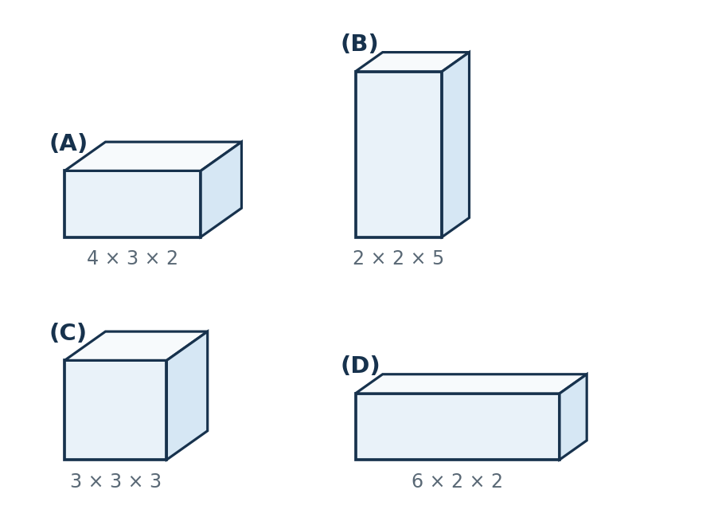  (A) Cuboid A  (B) Cuboid B  (C) Cuboid C  (D) Cuboid D
MASTERY HABIT | Count or multiply all three dimensions; visual length alone is not enough.

MEASUREMENT | Q15 QUESTION FAMILY
Calculate temperature changes across zero • Response style: Choose one answer
A — LEARN THE FORMAT | B — INDEPENDENT MATCH | C — TRANSFER CHECK
Q15A  At 6 am the temperature was -5°C. It rose by 12°C. What was the new temperature?  (A) -17°C  (B) -7°C  (C) 7°C  (D) 17°C | Q15B  At midday the temperature was 8°C. Overnight it fell by 15°C. What was the new temperature?  (A) -23°C  (B) -7°C  (C) 7°C  (D) 23°C | Q15C  The temperature was -12°C. It rose by 7°C, then fell by 4°C. What was the final temperature?  (A) -9°C  (B) -5°C  (C) 1°C  (D) 23°C
MASTERY HABIT | Represent the change on a number line and pay close attention to rise versus fall.

MEASUREMENT | Q27 QUESTION FAMILY
Read mass from a labelled scale • Response style: Choose one labelled arrow
A — LEARN THE FORMAT | B — INDEPENDENT MATCH | C — TRANSFER CHECK
Q27A  A recipe needs 500 g of flour. Which arrow shows this mass?  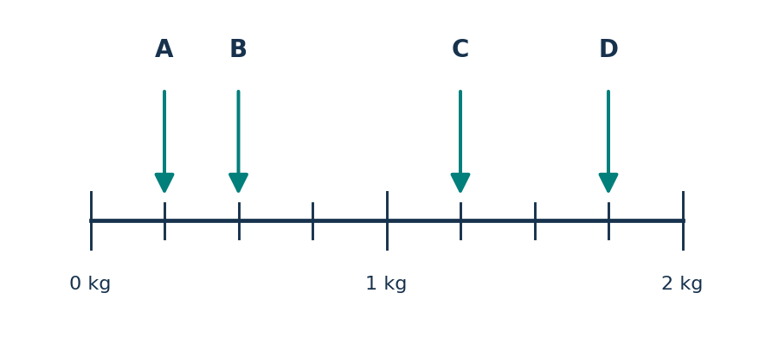  (A) Arrow A  (B) Arrow B  (C) Arrow C  (D) Arrow D | Q27B  A parcel has a mass of 1.5 kg. Which arrow shows this mass?  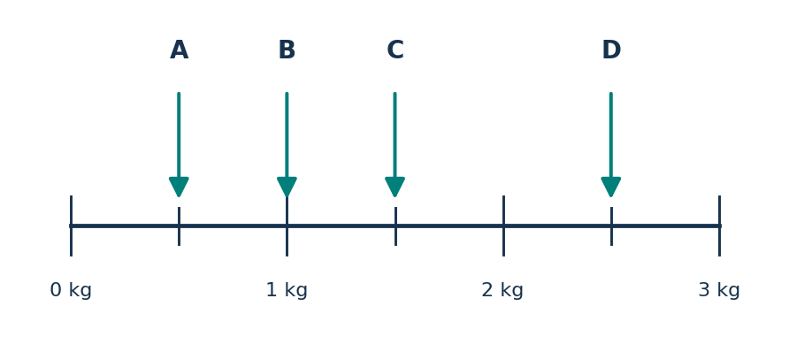  (A) Arrow A  (B) Arrow B  (C) Arrow C  (D) Arrow D | Q27C  A bag has a mass of 2.5 kg. Which arrow shows this mass?  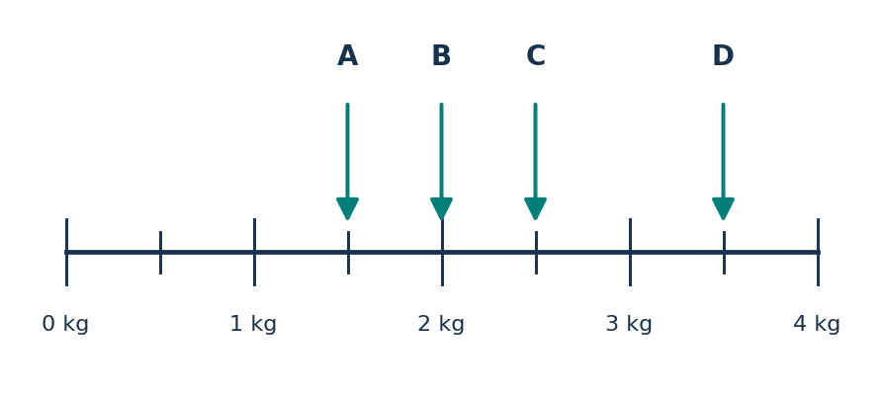  (A) Arrow A  (B) Arrow B  (C) Arrow C  (D) Arrow D
MASTERY HABIT | Convert grams to kilograms before locating the value between major marks.

MEASUREMENT | Q31 QUESTION FAMILY
Add a duration to a start time • Response style: Choose one finishing time
A — LEARN THE FORMAT | B — INDEPENDENT MATCH | C — TRANSFER CHECK
Q31A  A journey starts at 08:35 and takes 1 hour 47 minutes. What is the finishing time?  (A) 09:82  (B) 10:12  (C) 10:22  (D) 10:32 | Q31B  A film starts at 13:48 and lasts 2 hours 35 minutes. What is the finishing time?  (A) 15:73  (B) 16:13  (C) 16:18  (D) 16:23 | Q31C  A flight leaves at 22:55 and takes 3 hours 20 minutes. What time does it arrive the next day?  (A) 01:15  (B) 02:15  (C) 02:25  (D) 26:15
MASTERY HABIT | Add hours and minutes separately, regrouping every 60 minutes.

MEASUREMENT | Q39 QUESTION FAMILY
Multiply capacity and convert millilitres to litres • Response style: Write an answer in litres
A — LEARN THE FORMAT | B — INDEPENDENT MATCH | C — TRANSFER CHECK
Q39A  Each bottle holds 180 mL. There are 35 bottles. How much liquid is there altogether? Give your answer in litres.  Answer: __________________ | Q39B  Each carton holds 375 mL. There are 24 cartons. How much drink is there altogether? Give your answer in litres.  Answer: __________________ | Q39C  Each jar holds 425 mL. There are 36 jars. How much sauce is there altogether? Give your answer in litres.  Answer: __________________
MASTERY HABIT | Find the total in millilitres first, then divide by 1 000.

GEOMETRY | Q2 QUESTION FAMILY
Identify shapes containing more than one right angle • Response style: Choose two diagrams
A — LEARN THE FORMAT | B — INDEPENDENT MATCH | C — TRANSFER CHECK
Q2A  Choose the TWO shapes that have more than one right angle.  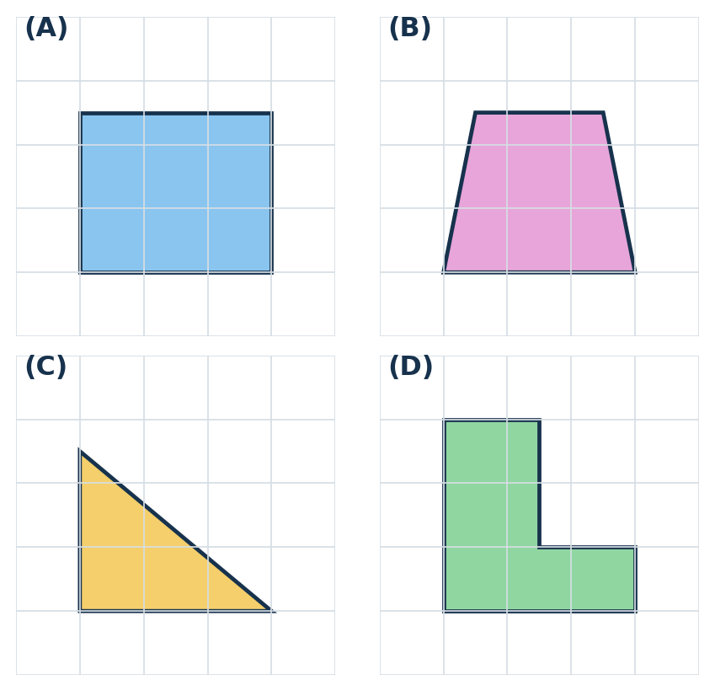  (A) Shape A  (B) Shape B  (C) Shape C  (D) Shape D | Q2B  Choose the TWO shapes that have more than one right angle.  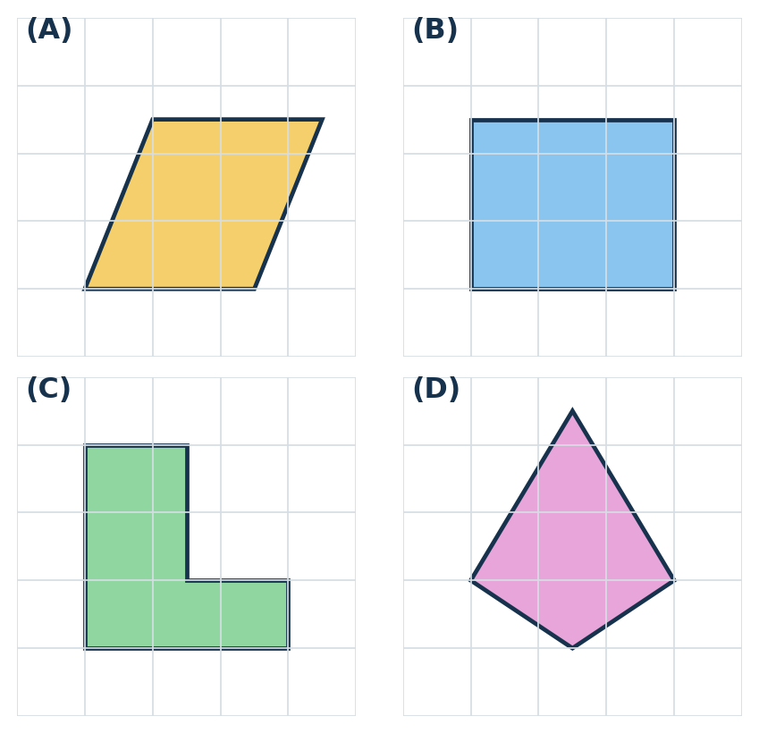  (A) Shape A  (B) Shape B  (C) Shape C  (D) Shape D | Q2C  Choose the TWO shapes that have more than one right angle.  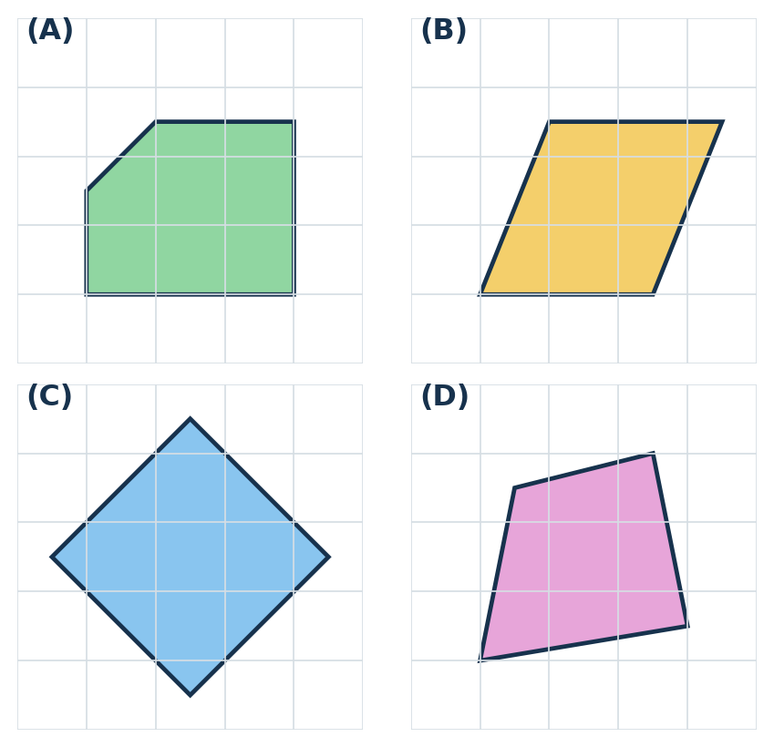  (A) Shape A  (B) Shape B  (C) Shape C  (D) Shape D
MASTERY HABIT | A right angle is preserved even when a square or rectangle is rotated.

GEOMETRY | Q8 QUESTION FAMILY
Recognise rotational symmetry • Response style: Choose all valid diagrams
A — LEARN THE FORMAT | B — INDEPENDENT MATCH | C — TRANSFER CHECK
Q8A  Choose all the shapes that have rotational symmetry.  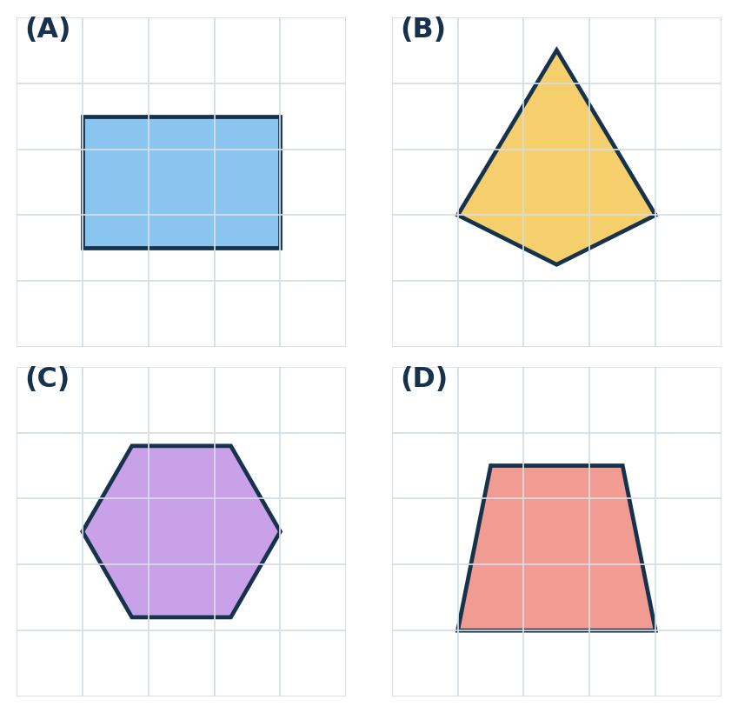  (A) Shape A  (B) Shape B  (C) Shape C  (D) Shape D | Q8B  Choose all the shapes that have rotational symmetry.  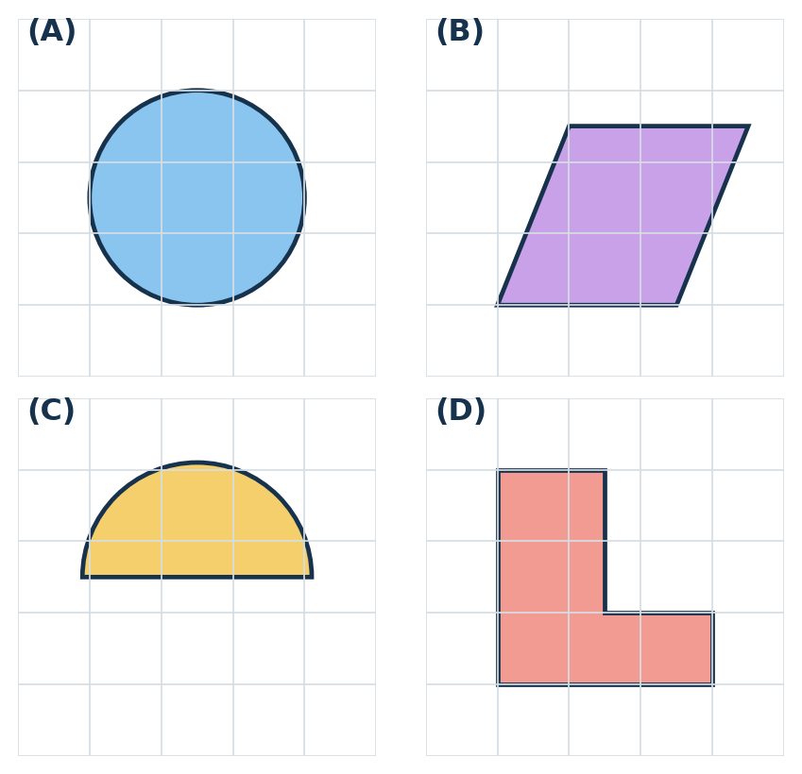  (A) Shape A  (B) Shape B  (C) Shape C  (D) Shape D | Q8C  Choose all the shapes that have rotational symmetry.  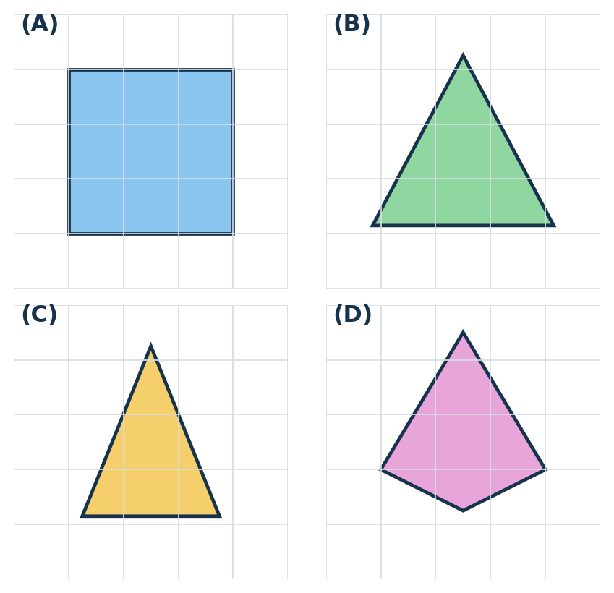  (A) Shape A  (B) Shape B  (C) Shape C  (D) Shape D
MASTERY HABIT | The shape must match its starting position before a complete 360° turn.

GEOMETRY | Q10 QUESTION FAMILY
Apply quarter and three-quarter turns to compass directions • Response style: Choose one direction
A — LEARN THE FORMAT | B — INDEPENDENT MATCH | C — TRANSFER CHECK
Q10A  Luca is facing North East. He makes a quarter turn to the right. Which direction is he facing?  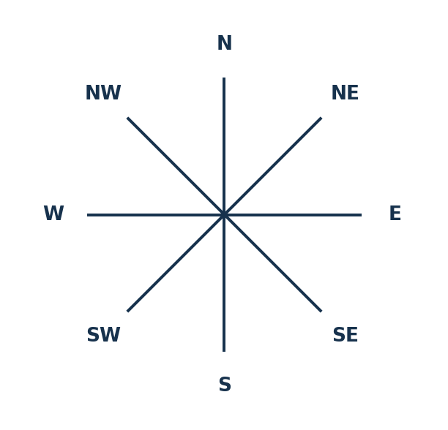  (A) North  (B) East  (C) South East  (D) South West | Q10B  Mere is facing South West. She makes a quarter turn to the left. Which direction is she facing?  (A) North West  (B) South East  (C) West  (D) North East | Q10C  Noah is facing East. He makes a three-quarter turn to the right. Which direction is he facing?  (A) North  (B) South  (C) West  (D) North East
MASTERY HABIT | Track the turn around all eight compass points; a quarter turn moves two positions.

GEOMETRY | Q11 QUESTION FAMILY
Classify quadrilaterals from their properties • Response style: Choose one shape name
A — LEARN THE FORMAT | B — INDEPENDENT MATCH | C — TRANSFER CHECK
Q11A  What is the name of this shape?  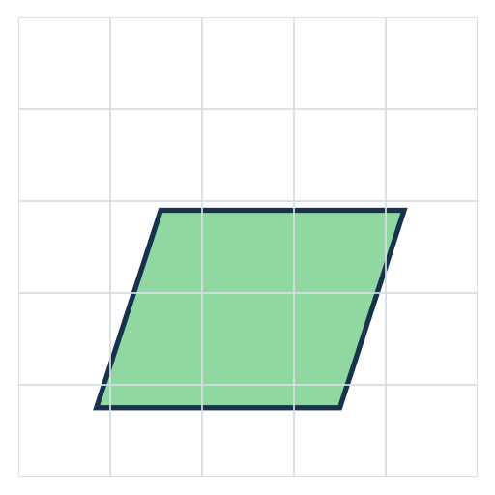  (A) kite  (B) parallelogram  (C) trapezium  (D) rhombus | Q11B  What is the name of this shape?  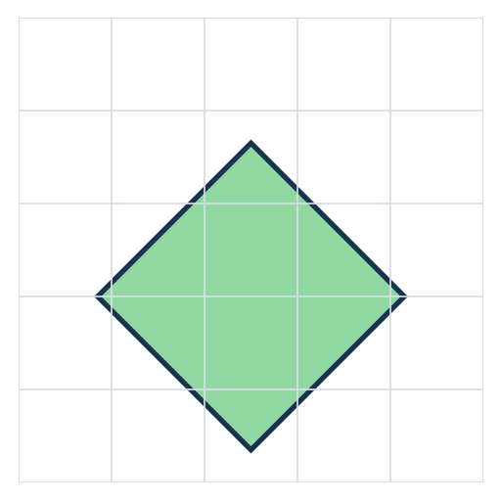  (A) kite  (B) parallelogram  (C) trapezium  (D) rhombus | Q11C  What is the name of this shape?  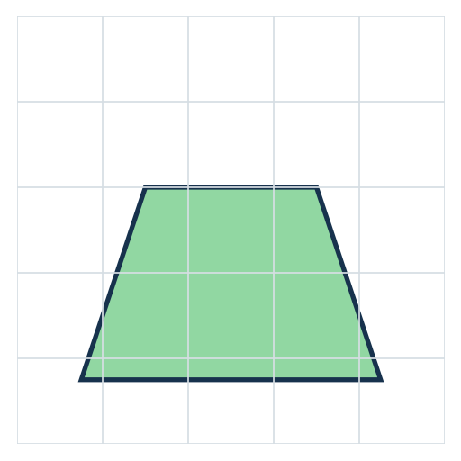  (A) kite  (B) parallelogram  (C) trapezium  (D) rhombus
MASTERY HABIT | Use parallel sides and equal-side markings rather than how the shape is oriented.

GEOMETRY | Q25 QUESTION FAMILY
Use angle sums and equal angles in isosceles triangles • Response style: Choose one angle
A — LEARN THE FORMAT | B — INDEPENDENT MATCH | C — TRANSFER CHECK
Q25A  The triangle is isosceles. The vertex angle is 40° and the base angles m and n are equal. What is angle m?  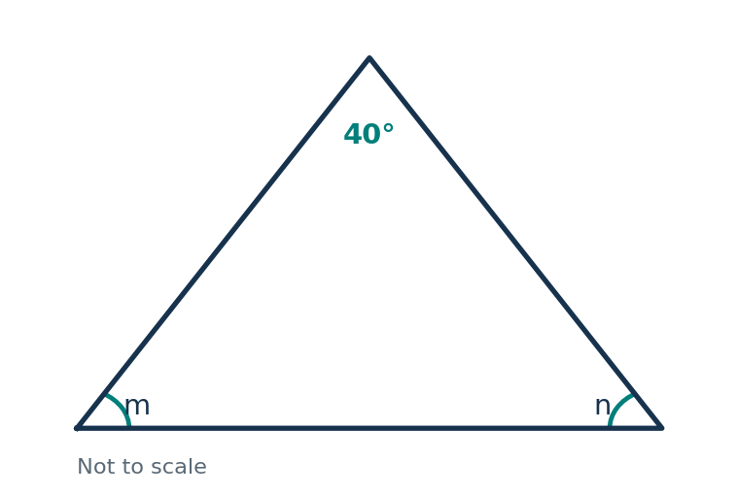  (A) 40°  (B) 60°  (C) 70°  (D) 140° | Q25B  The triangle is isosceles and has a right vertex angle. The base angles are equal. What is one base angle?  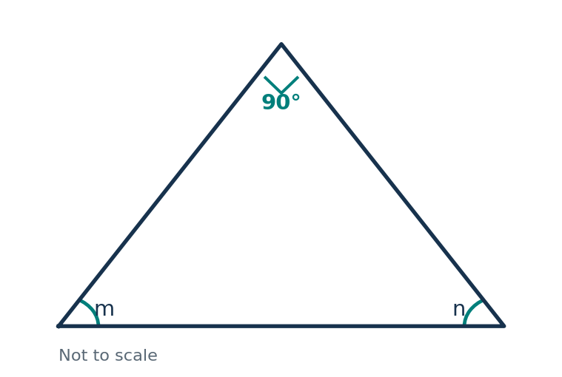  (A) 30°  (B) 45°  (C) 60°  (D) 90° | Q25C  The two equal base angles are each 62°. What is the vertex angle?  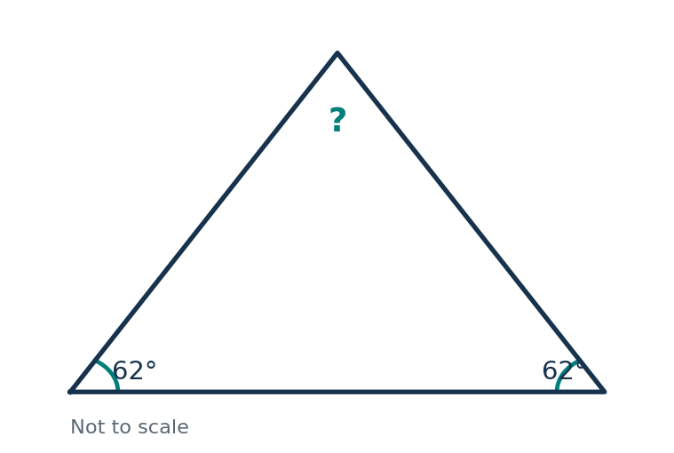  (A) 56°  (B) 62°  (C) 118°  (D) 124°
MASTERY HABIT | Subtract the known angle from 180°, then share the remainder if two angles are equal.

GEOMETRY | Q38 QUESTION FAMILY
Use symmetry in an isosceles trapezium to find coordinates • Response style: Choose one coordinate pair
A — LEARN THE FORMAT | B — INDEPENDENT MATCH | C — TRANSFER CHECK
Q38A  GDEF is an isosceles trapezium. Use the diagram to find the coordinates of D.  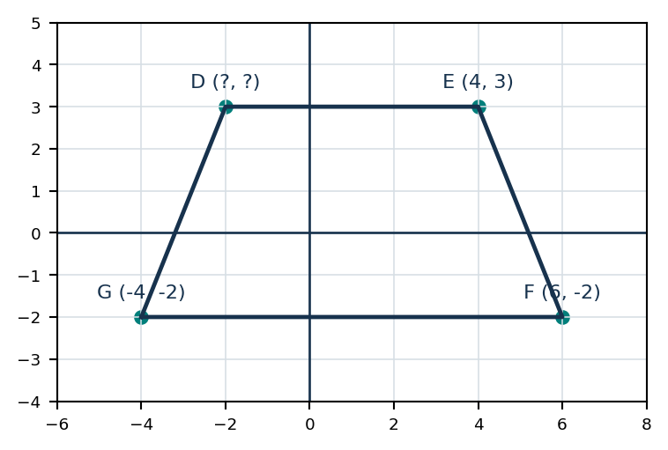  (A) (-2, 3)  (B) (2, 3)  (C) (-2, -3)  (D) (-4, 3) | Q38B  GDEF is an isosceles trapezium. Use the diagram to find the coordinates of D.  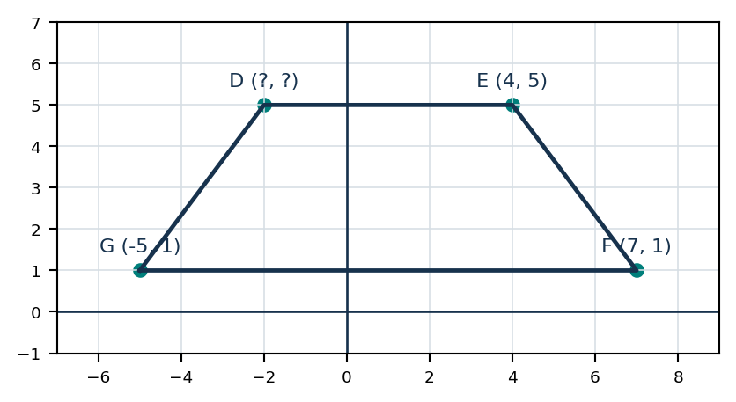  (A) (-5, 5)  (B) (2, 5)  (C) (-2, 5)  (D) (-2, 1) | Q38C  GDEF is an isosceles trapezium. Use the diagram to find the coordinates of D.  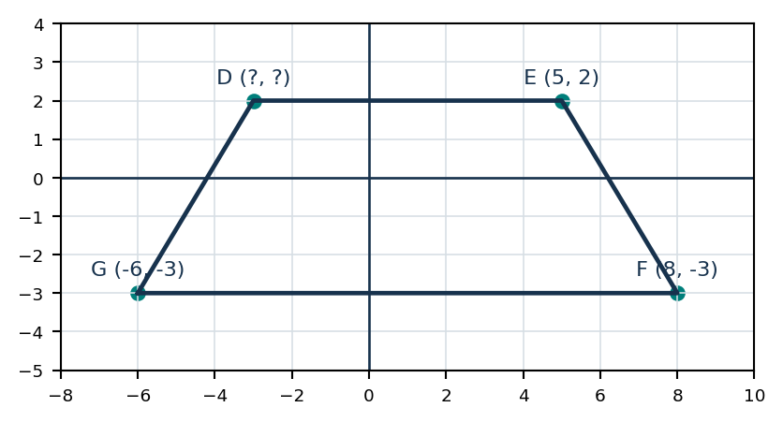  (A) (3, 2)  (B) (-3, -2)  (C) (-6, 2)  (D) (-3, 2)
MASTERY HABIT | Compare the equal horizontal insets from the two ends of the longer base.

GEOMETRY | Q40 QUESTION FAMILY
Apply a translation followed by reflection in the x-axis • Response style: Choose the final labelled shape
A — LEARN THE FORMAT | B — INDEPENDENT MATCH | C — TRANSFER CHECK
Q40A  Shape A is translated 5 squares right and 2 squares up, then reflected in the x-axis. Which labelled shape is the final image?  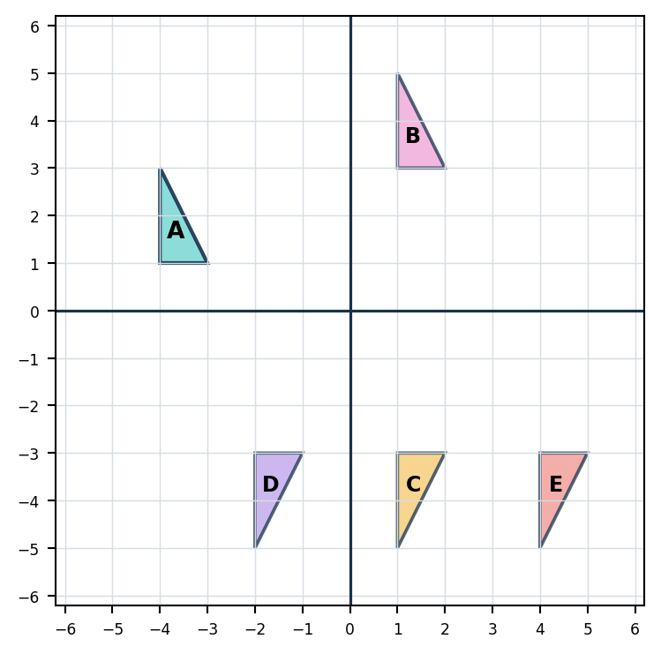  (A) Shape B  (B) Shape C  (C) Shape D  (D) Shape E | Q40B  Shape A is translated 3 squares left and 4 squares up, then reflected in the x-axis. Which labelled shape is the final image?  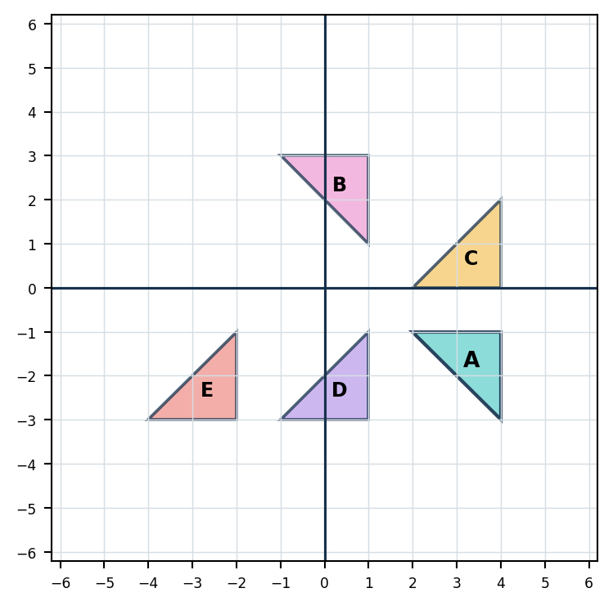  (A) Shape B  (B) Shape C  (C) Shape D  (D) Shape E | Q40C  Shape A is translated 4 squares left and 1 square down, then reflected in the x-axis. Which labelled shape is the final image?  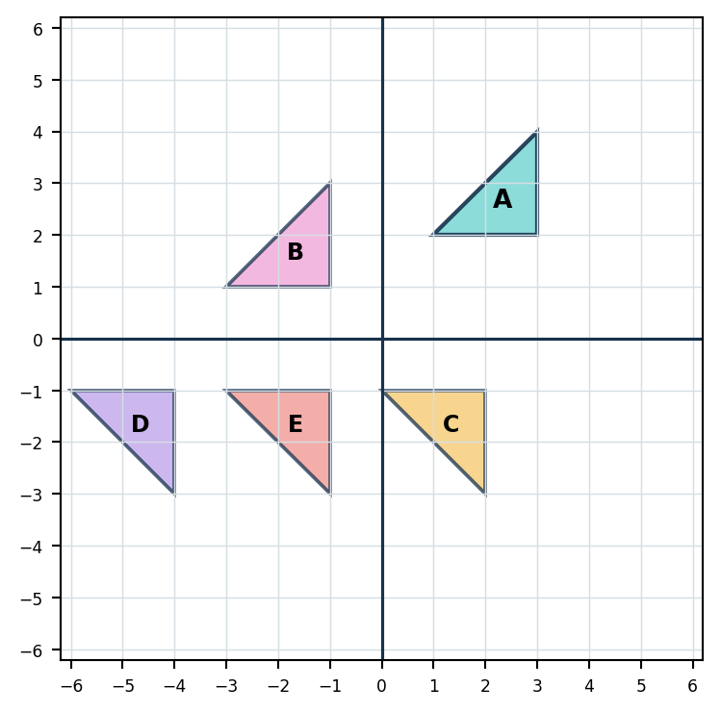  (A) Shape B  (B) Shape C  (C) Shape D  (D) Shape E
MASTERY HABIT | Complete the transformations in order; reflection in the x-axis changes the sign of y only.

STATISTICS & PROBABILITY | Q13 QUESTION FAMILY
Read one category from a stacked bar chart • Response style: Write one numerical answer
A — LEARN THE FORMAT | B — INDEPENDENT MATCH | C — TRANSFER CHECK
Q13A  The graph shows books borrowed. How many Comics books were borrowed on Tuesday?  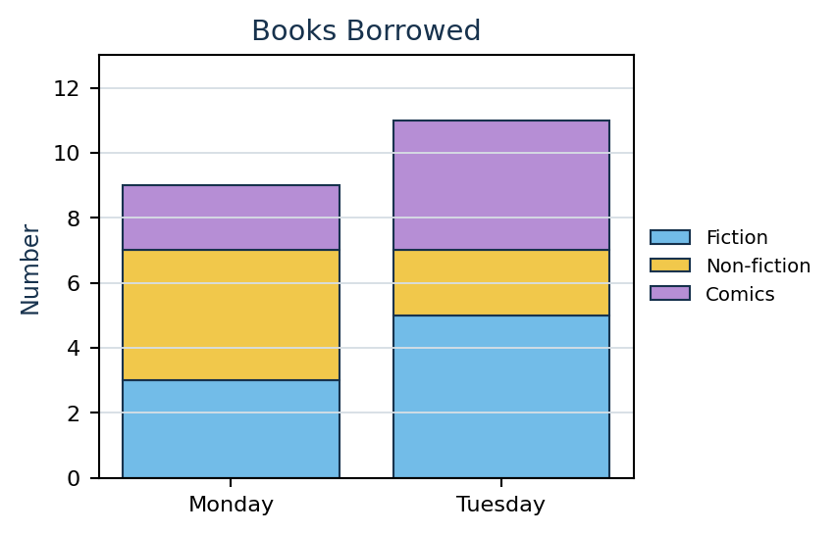  Answer: __________________ | Q13B  The graph shows goals scored. How many second-half goals did Rimu score?  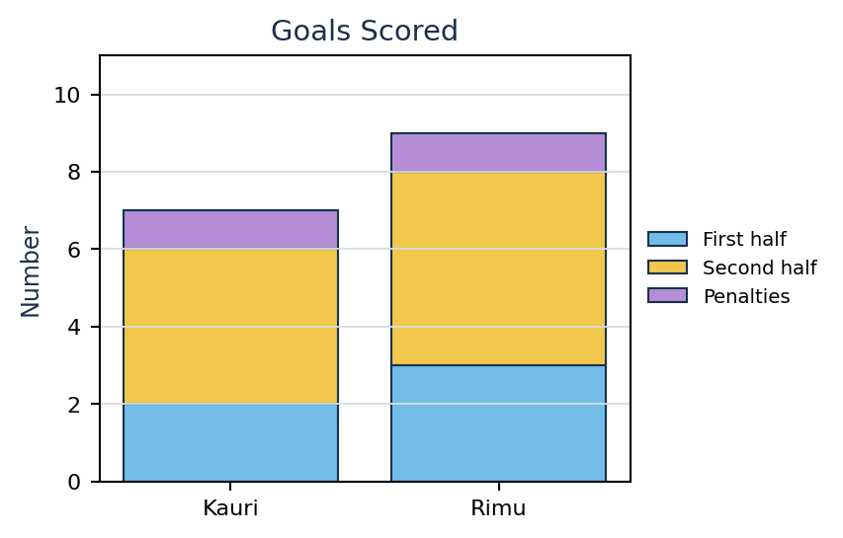  Answer: __________________ | Q13C  The graph shows recycling collected. How many bags of plastic were collected in Week 2?  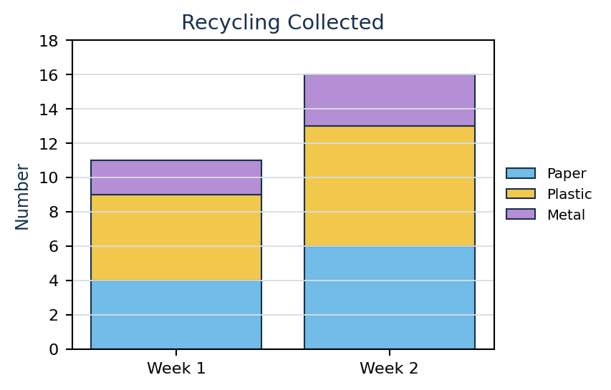  Answer: __________________
MASTERY HABIT | Read the top and bottom of the segment, then subtract; do not report the full bar height.

STATISTICS & PROBABILITY | Q16 QUESTION FAMILY
Find the mode from a data table • Response style: Choose one answer
A — LEARN THE FORMAT | B — INDEPENDENT MATCH | C — TRANSFER CHECK
Q16A  What is the mode of the values in the table?  (A) 4  (B) 5  (C) 5.5  (D) 7 | Q16B  What is the mode of the values in the table?  (A) 10  (B) 12  (C) 14  (D) 15 | Q16C  What is the mode of the values in the table?  (A) 8  (B) 8.25  (C) 8.5  (D) 9
  Day | Pages
  Mon | 4
  Tue | 6
  Wed | 4
  Thu | 7
  Fri | 4
  Sat | 6
  Session | Laps
  1 | 12
  2 | 15
  3 | 12
  4 | 18
  5 | 15
  6 | 12
  Trial | Time (s)
  1 | 8.5
  2 | 9.0
  3 | 8.5
  4 | 10.0
  5 | 9.5
  6 | 8.5
MASTERY HABIT | The mode is the value occurring most often, not the largest value or the mean.

STATISTICS & PROBABILITY | Q20 QUESTION FAMILY
Use theoretical probability despite previous experimental results • Response style: Choose one probability
A — LEARN THE FORMAT | B — INDEPENDENT MATCH | C — TRANSFER CHECK
Q20A  A fair coin was tossed 12 times and landed on heads 8 times. What is the probability of heads on the next toss?  (A) 1/2  (B) 8/12  (C) 4/12  (D) 1/8 | Q20B  A fair six-sided die was rolled 20 times and showed a 6 five times. What is the probability of rolling a 6 next?  (A) 1/20  (B) 5/20  (C) 1/6  (D) 5/6 | Q20C  A spinner has four equal sections; two are blue. It has just landed on blue three times in a row. What is the probability of blue next?  (A) 1/4  (B) 1/2  (C) 3/4  (D) 1
MASTERY HABIT | For a fair device, the next independent outcome is based on equally likely possibilities, not past results.

STATISTICS & PROBABILITY | Q32 QUESTION FAMILY
Infer a pictogram key from a known total • Response style: Choose one key value
A — LEARN THE FORMAT | B — INDEPENDENT MATCH | C — TRANSFER CHECK
Q32A  The pictogram represents 250 pieces of fruit in total. How many pieces does one full symbol represent?  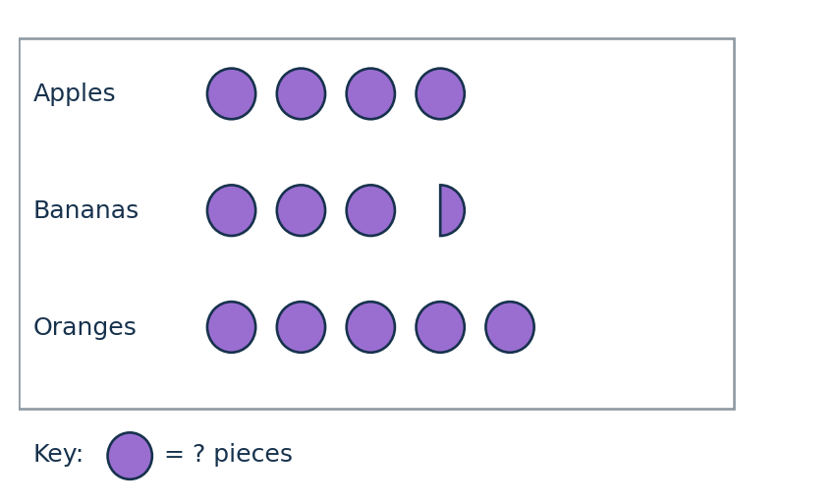  (A) 10  (B) 20  (C) 25  (D) 50 | Q32B  The pictogram represents 450 books in total. How many books does one full symbol represent?  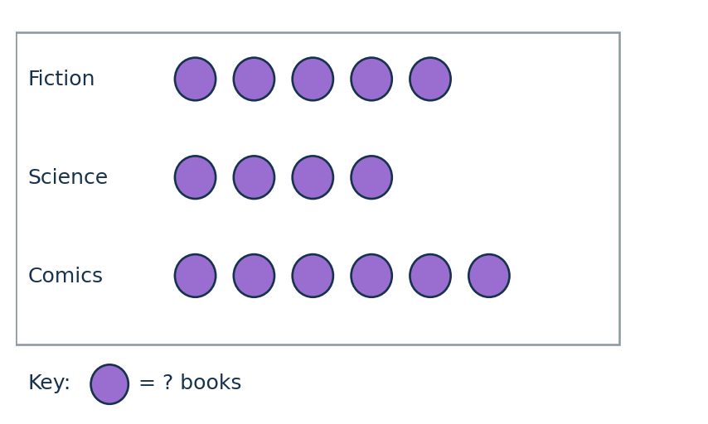  (A) 15  (B) 25  (C) 30  (D) 45 | Q32C  The pictogram represents 700 plants in total. How many plants does one full symbol represent?  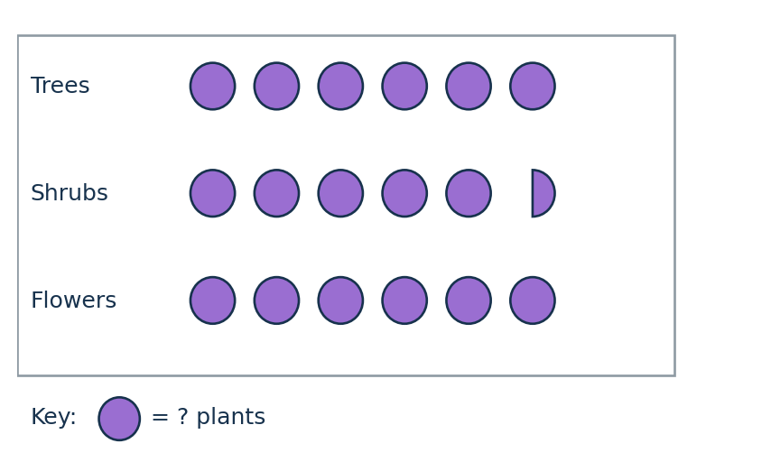  (A) 20  (B) 25  (C) 35  (D) 40
MASTERY HABIT | Count all symbols, including half symbols, then divide the known total by that count.

STATISTICS & PROBABILITY | Q36 QUESTION FAMILY
Express a category probability as a percentage • Response style: Choose one percentage
A — LEARN THE FORMAT | B — INDEPENDENT MATCH | C — TRANSFER CHECK
Q36A  A bag contains 8 red, 12 blue and 5 green counters. What is the probability of selecting green?  (A) 5%  (B) 12%  (C) 20%  (D) 25% | Q36B  A box contains 6 gold, 9 silver and 15 bronze tokens. What is the probability of selecting silver?  (A) 9%  (B) 30%  (C) 40%  (D) 50% | Q36C  A drawer contains 14 black, 21 white and 5 grey socks. What is the probability of selecting a black sock?  (A) 14%  (B) 21%  (C) 30%  (D) 35%
MASTERY HABIT | Add all categories for the denominator, then convert the selected fraction to a percentage.

STATISTICS & PROBABILITY | Q37 QUESTION FAMILY
Find a missing value when the mean is known • Response style: Write one numerical answer
A — LEARN THE FORMAT | B — INDEPENDENT MATCH | C — TRANSFER CHECK
Q37A  The mean of five scores is 16. Four scores are 14, 18, 16 and 17. What is the missing score?  Answer: __________________ | Q37B  The mean height of five students is 170 cm. Four heights are 165, 172, 168 and 175 cm. What is the missing height?  Answer: __________________ | Q37C  The mean of six test scores is 82. Five scores are 72, 84, 91, 78 and 85. What is the missing score?  Answer: __________________
MASTERY HABIT | Multiply the mean by the number of values, then subtract the known total.

FINANCIAL MATHS | Q33 QUESTION FAMILY
Substitute time into a cost formula with a fixed fee • Response style: Write one currency answer
A — LEARN THE FORMAT | B — INDEPENDENT MATCH | C — TRANSFER CHECK
Q33A  Bike hire is modelled by c = 42h + 25. What is the cost for 4 hours?  Answer: __________________ | Q33B  Kayak hire is modelled by c = 65h + 18. What is the cost for 5 hours?  Answer: __________________ | Q33C  A games room is modelled by c = 28h + 45. What is the cost for 7 hours?  Answer: __________________
MASTERY HABIT | Calculate the hourly portion first, then add the fixed fee once.

FINANCIAL MATHS | Q34 QUESTION FAMILY
Find the greatest whole number of hours within a budget • Response style: Choose one whole-number duration
A — LEARN THE FORMAT | B — INDEPENDENT MATCH | C — TRANSFER CHECK
Q34A  Bike hire costs c = 42h + 25. Mia has $300. What is the greatest number of whole hours she can afford?  (A) 5 hours  (B) 6 hours  (C) 7 hours  (D) 8 hours | Q34B  Kayak hire costs c = 65h + 18. Noah has $500. What is the greatest number of whole hours he can afford?  (A) 5 hours  (B) 6 hours  (C) 7 hours  (D) 8 hours | Q34C  A games room costs c = 28h + 45. A group has $400. What is the greatest number of whole hours it can book?  (A) 9 hours  (B) 10 hours  (C) 11 hours  (D) 12 hours
MASTERY HABIT | Subtract the fixed fee before dividing, then check the next whole hour is over budget.

FINANCIAL MATHS | Q35 QUESTION FAMILY
Adjust a cost formula when only the hourly rate is discounted • Response style: Choose one revised formula
A — LEARN THE FORMAT | B — INDEPENDENT MATCH | C — TRANSFER CHECK
Q35A  Hire costs c = 48h + 30. The hourly rate is reduced by 25%; the fixed fee is unchanged. Which formula is correct?  (A) c = 12h + 30  (B) c = 36h + 30  (C) c = 48h + 22.5  (D) c = 0.75(48h + 30) | Q35B  Hire costs c = 65h + 20. The hourly rate is reduced by 20%; the fixed fee is unchanged. Which formula is correct?  (A) c = 13h + 20  (B) c = 45h + 20  (C) c = 52h + 20  (D) c = 0.8(65h + 20) | Q35C  Hire costs c = 72h + 45. The hourly rate is reduced by one third; the fixed fee is unchanged. Which formula is correct?  (A) c = 48h + 45  (B) c = 24h + 45  (C) c = 72h + 30  (D) c = (72h + 45) ÷ 3
MASTERY HABIT | Discount the hourly term but leave the fixed fee unchanged unless told otherwise.

TEACHER ANSWER GUIDE
Answers by question family • 1 of 3
SMART | Skill focus | A answer | B answer | C answer
Q3 | Multiply a four-digit number by a one-digit number | 7 218 | 12 432 | 25 302
Q5 | Add decimals with unlike numbers of decimal places | C - 16.86 | B - 46.22 | D - 134.78
Q7 | Multiply multiples of ten using place value | 2 800 | 18 000 | 20 000
Q9 | Simplify a fraction using a common factor | C - 3/5 | B - 2/3 | D - 2/3
Q12 | Round whole numbers to a stated place value | A - 63 000 | D - 149 000 | C - 910 000
Q18 | Convert common fractions to percentages | C - 75% | B - 70% | D - 45%
Q19 | Apply order of operations, including powers | B - 13 | C - 16 | D - 31
Q21 | Identify the value of a digit in a large number | B - 80 000 | C - 500 000 | B - 40 000
Q22 | Find the difference between a value and a large target | 257 350 views | $613 250 | 3 254 100 downloads
Q23 | Calculate a percentage decrease from a large whole number | C - 313 200 | B - 500 000 | D - 408 000
Q24 | Use division in a capacity context and round up | C - 7 buses | B - 12 tables | D - 22 boxes
Q28 | Express a used amount as a fraction of a whole quantity | A - 1/4 | C - 7/20 | B - 3/10
Q29 | Scale recipe quantities using proportional reasoning | 450 g | 1 500 mL | 640 g
Q30 | Use the lowest common multiple in repeating-time contexts | C - 10:24 | B - 1:51 pm | D - 10:12 am

TEACHER ANSWER GUIDE
Answers by question family • 2 of 3
SMART | Skill focus | A answer | B answer | C answer
Q1 | Find an unknown in a two-step number sentence | 4 | 7 | 8
Q4 | Continue a sequence with a constant difference | 49 750 | 317 600 | 858 900
Q17 | Translate a purchasing context into an algebraic expression | D - 4p + d | B - 3l + 12 | C - 2a + 3c
Q26 | Use differences between two grouped equations to find one item | 6 kg | 8 kg | 8 kg
Q6 | Find a missing rectangle dimension from area | B - 7 cm | C - 9 m | D - 13 cm
Q14 | Compare the volumes of cuboids | B - 18 unit cubes | B - 20 unit cubes | C - 27 unit cubes
Q15 | Calculate temperature changes across zero | C - 7°C | B - -7°C | A - -9°C
Q27 | Read mass from a labelled scale | B | C | C
Q31 | Add a duration to a start time | C - 10:22 | D - 16:23 | B - 02:15
Q39 | Multiply capacity and convert millilitres to litres | 6.3 L | 9 L | 15.3 L
Q2 | Identify shapes containing more than one right angle | A and D | B and C | A and C
Q8 | Recognise rotational symmetry | A and C | A and B | A and B
Q10 | Apply quarter and three-quarter turns to compass directions | C - South East | B - South East | A - North

TEACHER ANSWER GUIDE
Answers by question family • 3 of 3
SMART | Skill focus | A answer | B answer | C answer
Q11 | Classify quadrilaterals from their properties | B - parallelogram | D - rhombus | C - trapezium
Q25 | Use angle sums and equal angles in isosceles triangles | C - 70° | B - 45° | A - 56°
Q38 | Use symmetry in an isosceles trapezium to find coordinates | A - (-2, 3) | C - (-2, 5) | D - (-3, 2)
Q40 | Apply a translation followed by reflection in the x-axis | B - Shape C | C - Shape D | D - Shape E
Q13 | Read one category from a stacked bar chart | 4 books | 5 goals | 7 bags
Q16 | Find the mode from a data table | A - 4 | B - 12 | C - 8.5
Q20 | Use theoretical probability despite previous experimental results | A - 1/2 | C - 1/6 | B - 1/2
Q32 | Infer a pictogram key from a known total | B - 20 | C - 30 | D - 40
Q36 | Express a category probability as a percentage | C - 20% | B - 30% | D - 35%
Q37 | Find a missing value when the mean is known | 15 | 170 cm | 82
Q33 | Substitute time into a cost formula with a fixed fee | $193 | $343 | $241
Q34 | Find the greatest whole number of hours within a budget | B - 6 hours | C - 7 hours | D - 12 hours
Q35 | Adjust a cost formula when only the hourly rate is discounted | B - c = 36h + 30 | C - c = 52h + 20 | A - c = 48h + 45

