YEAR 8 MATHEMATICS
SMART-format mastery question bank
120 original practice questions mapped to all 40 item types in the 2026 Year 8 paper
A — LEARN THE FORMAT | B — INDEPENDENT MATCH | C — TRANSFER CHECK
Model, annotate and discuss. Students learn the wording and response conventions. | Use independently in lessons or homework. Demand closely matches the SMART item family. | Hold back for exit tickets or mini-tests. Includes new numbers or a small transfer twist.

Recommended use
• Teach with A, practise with B, and protect C until students work independently.
• Require students to show working even when the response is multiple choice.
• Discuss distractors: students should explain why each incorrect option is tempting.
• For homework, select 8-12 mixed B questions rather than giving an entire strand at once.
• A student is secure when they can solve at least two variants and explain the method.

Bank structure
Strand | Item families | Questions | Suggested use
Number | 13 | 39 | Lessons • homework • checks
Algebra | 3 | 9 | Lessons • homework • checks
Measurement | 7 | 21 | Lessons • homework • checks
Geometry | 7 | 21 | Lessons • homework • checks
Statistics & Probability | 6 | 18 | Lessons • homework • checks
Financial Maths | 4 | 12 | Lessons • homework • checks

QUESTION BANK MAP
Item families and teaching focus • 1 of 2
SMART | Strand | Skill focus | Practice codes
Q4 | Number | Divide a five-digit whole number by a one-digit number | Q4A-C
Q6 | Number | Identify prime numbers from a mixed list | Q6A-C
Q11 | Number | Apply order of operations, including powers | Q11A-C
Q13 | Number | Round decimals to a stated place value | Q13A-C
Q14 | Number | Express a number as a product of prime factors | Q14A-C
Q16 | Number | Compare decimal multiplication and division results with 1 | Q16A-C
Q18 | Number | Check multiplication statements involving fractions | Q18A-C
Q21 | Number | Use factors, multiples and square numbers together | Q21A-C
Q25 | Number | Add fractions with unlike denominators | Q25A-C
Q26 | Number | Use the lowest common multiple in repeating-time contexts | Q26A-C
Q27 | Number | Recover a whole amount from the fraction remaining | Q27A-C
Q28 | Number | Find one part of a total divided in a ratio | Q28A-C
Q29 | Number | Find a fraction of a journey distance | Q29A-C
Q10 | Algebra | Simplify an expression by collecting like terms | Q10A-C
Q17 | Algebra | Translate a multi-step comparison into an algebraic expression | Q17A-C
Q20 | Algebra | Substitute into a formula containing brackets and division | Q20A-C
Q2 | Measurement | Find the difference between positive and negative temperatures | Q2A-C
Q3 | Measurement | Read a mass scale and convert kilograms to grams | Q3A-C
Q30 | Measurement | Use a map scale to convert distance to map length | Q30A-C
Q31 | Measurement | Calculate travel time from distance and average speed | Q31A-C

QUESTION BANK MAP
Item families and teaching focus • 2 of 2
SMART | Strand | Skill focus | Practice codes
Q36 | Measurement | Multiply a repeated length by the number of lengths | Q36A-C
Q37 | Measurement | Find cuboid depth from volume, length and width | Q37A-C
Q38 | Measurement | Find the area of a uniform border around a rectangle | Q38A-C
Q1 | Geometry | Classify a quadrilateral from its shape | Q1A-C
Q5 | Geometry | Identify a labelled point from ordered coordinates | Q5A-C
Q7 | Geometry | Use angle relationships on parallel lines | Q7A-C
Q9 | Geometry | Recognise a valid net for a triangular prism | Q9A-C
Q12 | Geometry | Apply quarter turns to compass directions | Q12A-C
Q33 | Geometry | Calculate an interior angle of a regular polygon | Q33A-C
Q35 | Geometry | Use symmetry in an isosceles trapezium to find a coordinate | Q35A-C
Q8 | Statistics & Probability | Find a theoretical probability from category counts | Q8A-C
Q15 | Statistics & Probability | Identify the modal category from a two-way table | Q15A-C
Q19 | Statistics & Probability | Interpret grouped frequencies and select a true statement | Q19A-C
Q32 | Statistics & Probability | Use a percentage to predict a likely count | Q32A-C
Q34 | Statistics & Probability | Find a missing value when the mean is known | Q34A-C
Q40 | Statistics & Probability | Compare ranges from a summary table | Q40A-C
Q22 | Financial Maths | Substitute time into a cost rule with a fixed fee | Q22A-C
Q23 | Financial Maths | Match a fixed-fee cost rule to its graph | Q23A-C
Q24 | Financial Maths | Apply a percentage discount to both parts of a cost rule | Q24A-C
Q39 | Financial Maths | Use rate and gross income to find hours worked | Q39A-C

NUMBER | Q4 QUESTION FAMILY
Divide a five-digit whole number by a one-digit number • Response style: Write one numerical answer
A — LEARN THE FORMAT | B — INDEPENDENT MATCH | C — TRANSFER CHECK
Q4A  14 742 / 6 =  Answer: __________________ | Q4B  23 184 / 8 =  Answer: __________________ | Q4C  38 556 / 9 =  Answer: __________________
MASTERY HABIT | Estimate the quotient first, then check by multiplication.

NUMBER | Q6 QUESTION FAMILY
Identify prime numbers from a mixed list • Response style: Choose all valid answers
A — LEARN THE FORMAT | B — INDEPENDENT MATCH | C — TRANSFER CHECK
Q6A  Choose all the prime numbers.  (A) 11  (B) 21  (C) 31  (D) 41  (E) 51 | Q6B  Choose all the prime numbers.  (A) 17  (B) 27  (C) 37  (D) 47  (E) 57 | Q6C  Choose all the prime numbers.  (A) 23  (B) 33  (C) 43  (D) 53  (E) 63
MASTERY HABIT | Test divisibility systematically; 1 is not prime and every even number above 2 is composite.

NUMBER | Q11 QUESTION FAMILY
Apply order of operations, including powers • Response style: Choose one answer
A — LEARN THE FORMAT | B — INDEPENDENT MATCH | C — TRANSFER CHECK
Q11A  7^2 - 5 x 3 =  (A) 6  (B) 34  (C) 42  (D) 132 | Q11B  48 / 6 + 3^2 =  (A) 9  (B) 11  (C) 17  (D) 73 | Q11C  2 x (5^2 - 9) =  (A) 16  (B) 23  (C) 41  (D) 32
MASTERY HABIT | Calculate powers first, then multiplication or division, then addition or subtraction.

NUMBER | Q13 QUESTION FAMILY
Round decimals to a stated place value • Response style: Choose one answer
A — LEARN THE FORMAT | B — INDEPENDENT MATCH | C — TRANSFER CHECK
Q13A  Which is 47.2864 rounded to the nearest hundredth?  (A) 47  (B) 47.28  (C) 47.29  (D) 47.286 | Q13B  Which is 125.944 rounded to the nearest tenth?  (A) 126  (B) 125.9  (C) 125.94  (D) 125.95 | Q13C  Which is 8.9951 rounded to the nearest thousandth?  (A) 9  (B) 8.99  (C) 8.996  (D) 8.995
MASTERY HABIT | Identify the rounding digit, then inspect only the digit immediately to its right.

NUMBER | Q14 QUESTION FAMILY
Express a number as a product of prime factors • Response style: Choose one answer
A — LEARN THE FORMAT | B — INDEPENDENT MATCH | C — TRANSFER CHECK
Q14A  What is the prime factorisation of 18?  (A) 2 x 9  (B) 2 x 3^2  (C) 3 x 6  (D) 1 x 18 | Q14B  What is the prime factorisation of 40?  (A) 4 x 10  (B) 2 x 20  (C) 2^3 x 5  (D) 5 x 8 | Q14C  What is the prime factorisation of 84?  (A) 2 x 42  (B) 4 x 21  (C) 2 x 3 x 14  (D) 2^2 x 3 x 7
MASTERY HABIT | Use a factor tree and continue until every factor is prime.

NUMBER | Q16 QUESTION FAMILY
Compare decimal multiplication and division results with 1 • Response style: Choose two calculations
A — LEARN THE FORMAT | B — INDEPENDENT MATCH | C — TRANSFER CHECK
Q16A  Choose the TWO calculations that have an answer less than 1.  (A) 0.03 x 10  (B) 0.04 x 100  (C) 6 / 100  (D) 80 / 10 | Q16B  Choose the TWO calculations that have an answer less than 1.  (A) 0.7 x 10  (B) 0.006 x 100  (C) 45 / 10  (D) 300 / 1000 | Q16C  Choose the TWO calculations that have an answer less than 1.  (A) 0.0008 x 1000  (B) 0.09 x 10  (C) 12 / 10  (D) 900 / 100
MASTERY HABIT | Use place value to predict whether multiplying or dividing makes the number larger or smaller.

NUMBER | Q18 QUESTION FAMILY
Check multiplication statements involving fractions • Response style: Choose all true calculations
A — LEARN THE FORMAT | B — INDEPENDENT MATCH | C — TRANSFER CHECK
Q18A  Choose all the calculations that are true.  (A) 5 x 1/8 = 5/8  (B) 1/4 x 1/3 = 1/12  (C) 3 x 2/5 = 6/15  (D) 2/7 x 4 = 8/28 | Q18B  Choose all the calculations that are true.  (A) 7 x 1/9 = 7/9  (B) 2/3 x 1/5 = 2/15  (C) 4 x 3/7 = 12/28  (D) 5/6 x 2 = 10/12 | Q18C  Choose all the calculations that are true.  (A) 6 x 1/11 = 6/11  (B) 1/2 x 1/7 = 2/14  (C) 5 x 3/8 = 15/8  (D) 4/9 x 3 = 12/27
MASTERY HABIT | Multiply whole numbers by the numerator; when multiplying fractions, multiply both numerators and both denominators.

NUMBER | Q21 QUESTION FAMILY
Use factors, multiples and square numbers together • Response style: Choose one possible number
A — LEARN THE FORMAT | B — INDEPENDENT MATCH | C — TRANSFER CHECK
Q21A  A number has 4 and 9 as factors, is a multiple of 6, and is a square number. Which could it be?  (A) 18  (B) 36  (C) 54  (D) 72 | Q21B  A number has 5 and 10 as factors, is a multiple of 4, and is a square number. Which could it be?  (A) 40  (B) 100  (C) 120  (D) 200 | Q21C  A number has 7 and 14 as factors, is a multiple of 4, and is a square number. Which could it be?  (A) 98  (B) 144  (C) 196  (D) 252
MASTERY HABIT | Test each condition separately, then keep only the option satisfying all of them.

NUMBER | Q25 QUESTION FAMILY
Add fractions with unlike denominators • Response style: Choose one answer
A — LEARN THE FORMAT | B — INDEPENDENT MATCH | C — TRANSFER CHECK
Q25A  Mila walks 2/3 km, then 1/4 km. How far does she walk in total?  (A) 3/7 km  (B) 3/12 km  (C) 11/12 km  (D) 3/4 km | Q25B  Noah cycles 5/6 km, then 1/8 km. How far does he cycle in total?  (A) 6/14 km  (B) 6/48 km  (C) 21/24 km  (D) 23/24 km | Q25C  A ribbon is made from pieces 3/5 m and 7/10 m long. What is the total length?  (A) 10/15 m  (B) 13/10 m  (C) 10/10 m  (D) 21/50 m
MASTERY HABIT | Find a common denominator before adding; never add the denominators.

NUMBER | Q26 QUESTION FAMILY
Use the lowest common multiple in repeating-time contexts • Response style: Choose the next common time
A — LEARN THE FORMAT | B — INDEPENDENT MATCH | C — TRANSFER CHECK
Q26A  Two lights flash every 5 minutes and every 8 minutes. They flash together at 10:00. When do they next flash together?  (A) 10:13  (B) 10:20  (C) 10:40  (D) 11:00 | Q26B  Two bells ring every 6 minutes and every 9 minutes. They ring together at 1:15 pm. When do they next ring together?  (A) 1:30 pm  (B) 1:33 pm  (C) 1:39 pm  (D) 2:09 pm | Q26C  Two signals sound every 12 minutes and every 15 minutes. They sound together at 08:20. When do they next sound together?  (A) 08:47  (B) 08:50  (C) 09:00  (D) 09:20
MASTERY HABIT | Find the lowest common multiple of the two time intervals, then add it once.

NUMBER | Q27 QUESTION FAMILY
Recover a whole amount from the fraction remaining • Response style: Choose one starting amount
A — LEARN THE FORMAT | B — INDEPENDENT MATCH | C — TRANSFER CHECK
Q27A  Aroha delivers 2/5 of her leaflets and has 240 left. How many leaflets did she have at the start?  (A) 300  (B) 360  (C) 400  (D) 600 | Q27B  A shop sells 3/7 of its tickets and has 360 left. How many tickets did it have at the start?  (A) 540  (B) 630  (C) 720  (D) 840 | Q27C  A class uses 5/12 of its paper and has 350 sheets left. How many sheets did it have at the start?  (A) 420  (B) 500  (C) 550  (D) 600
MASTERY HABIT | Identify the fraction remaining, match it to the known amount, then scale to the whole.

NUMBER | Q28 QUESTION FAMILY
Find one part of a total divided in a ratio • Response style: Choose one answer
A — LEARN THE FORMAT | B — INDEPENDENT MATCH | C — TRANSFER CHECK
Q28A  A drink uses cordial and water in the ratio 2:5. There are 1 400 mL altogether. How much water is used?  (A) 200 mL  (B) 400 mL  (C) 700 mL  (D) 1 000 mL | Q28B  Red and blue beads are in the ratio 3:7. There are 250 beads altogether. How many are blue?  (A) 75  (B) 100  (C) 175  (D) 210 | Q28C  Flour and oats are mixed in the ratio 4:1. The mixture has a mass of 750 g. How much is flour?  (A) 150 g  (B) 600 g  (C) 625 g  (D) 700 g
MASTERY HABIT | Add the ratio parts first, find the value of one part, then multiply by the required number of parts.

NUMBER | Q29 QUESTION FAMILY
Find a fraction of a journey distance • Response style: Choose one answer
A — LEARN THE FORMAT | B — INDEPENDENT MATCH | C — TRANSFER CHECK
Q29A  A journey is 240 km. A driver stops after 3/8 of the journey. How far has the driver travelled?  (A) 30 km  (B) 90 km  (C) 120 km  (D) 150 km | Q29B  A route is 360 km. A bus stops after 5/12 of the route. How far has it travelled?  (A) 30 km  (B) 120 km  (C) 150 km  (D) 210 km | Q29C  A trail is 450 km. A cyclist completes 7/10 of it. How far has the cyclist travelled?  (A) 45 km  (B) 70 km  (C) 300 km  (D) 315 km
MASTERY HABIT | Multiply the total distance by the fraction and simplify before calculating.

ALGEBRA | Q10 QUESTION FAMILY
Simplify an expression by collecting like terms • Response style: Choose one expression
A — LEARN THE FORMAT | B — INDEPENDENT MATCH | C — TRANSFER CHECK
Q10A  Simplify 4a + 3b + 2a - b.  (A) 6a + 4b  (B) 6a + 2b  (C) 2a + 2b  (D) 8ab | Q10B  Simplify 7m - 2n - 3m + 5n.  (A) 10m + 7n  (B) 4m - 7n  (C) 4m + 3n  (D) 9mn | Q10C  Simplify 5x + 4y - 2x - 7y.  (A) 7x + 11y  (B) 3x + 3y  (C) 7x - 3y  (D) 3x - 3y
MASTERY HABIT | Combine coefficients only when the variable part is the same.

ALGEBRA | Q17 QUESTION FAMILY
Translate a multi-step comparison into an algebraic expression • Response style: Choose one expression
A — LEARN THE FORMAT | B — INDEPENDENT MATCH | C — TRANSFER CHECK
Q17A  Kai has n cards. Ana has 4 fewer than Kai. Leo has twice as many cards as Ana. Which expression represents Leo's cards?  (A) 2n  (B) n - 4  (C) 2n - 4  (D) 2(n - 4) | Q17B  Sami has p books. Lee has 7 more than Sami. Mo has 3 times as many books as Lee. Which expression represents Mo's books?  (A) 3p + 7  (B) p + 21  (C) 3(p + 7)  (D) 7 - 3p | Q17C  Rina has t stickers. Ari has 6 fewer than Rina. Bea has 4 times as many stickers as Ari. Which expression represents Bea's stickers?  (A) 4t - 6  (B) 4(t - 6)  (C) t - 24  (D) 6 - 4t
MASTERY HABIT | Build the expression in the same order as the story; brackets preserve the first comparison.

ALGEBRA | Q20 QUESTION FAMILY
Substitute into a formula containing brackets and division • Response style: Choose one answer
A — LEARN THE FORMAT | B — INDEPENDENT MATCH | C — TRANSFER CHECK
Q20A  The formula is t = n(n - 3) / 2. What is t when n = 12?  (A) 108  (B) 66  (C) 54  (D) 18 | Q20B  The formula is p = m(m + 1) / 2. What is p when m = 9?  (A) 90  (B) 45  (C) 36  (D) 10 | Q20C  The formula is v = k(k - 5) / 2. What is v when k = 15?  (A) 150  (B) 100  (C) 50  (D) 75
MASTERY HABIT | Substitute first, evaluate the brackets, multiply, then divide.

MEASUREMENT | Q2 QUESTION FAMILY
Find the difference between positive and negative temperatures • Response style: Choose one answer
A — LEARN THE FORMAT | B — INDEPENDENT MATCH | C — TRANSFER CHECK
Q2A  The temperature is -5 degrees C in one town and 8 degrees C in another. What is the difference?  (A) 3 degrees C  (B) 8 degrees C  (C) 13 degrees C  (D) -13 degrees C | Q2B  The temperature is -7 degrees C at dawn and 4 degrees C at midday. What is the difference?  (A) 3 degrees C  (B) 11 degrees C  (C) -3 degrees C  (D) -11 degrees C | Q2C  One freezer is -12 degrees C and another is 3 degrees C. What is the difference?  (A) 9 degrees C  (B) 12 degrees C  (C) -9 degrees C  (D) 15 degrees C
MASTERY HABIT | Place both temperatures on a number line and count the full distance across zero.

MEASUREMENT | Q3 QUESTION FAMILY
Read a mass scale and convert kilograms to grams • Response style: Choose one answer
A — LEARN THE FORMAT | B — INDEPENDENT MATCH | C — TRANSFER CHECK
Q3A  The arrow shows a mass on the scale. What is the mass in grams?  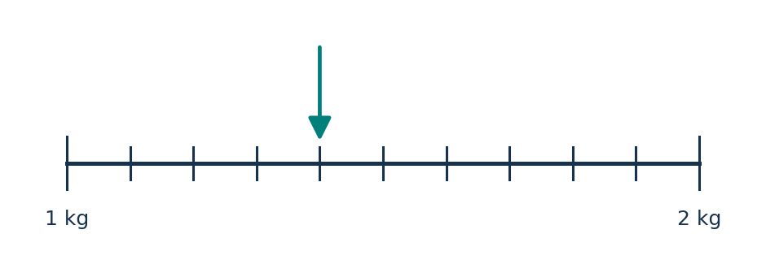  (A) 140 g  (B) 1 040 g  (C) 1 400 g  (D) 14 000 g | Q3B  The arrow shows a mass on the scale. What is the mass in grams?  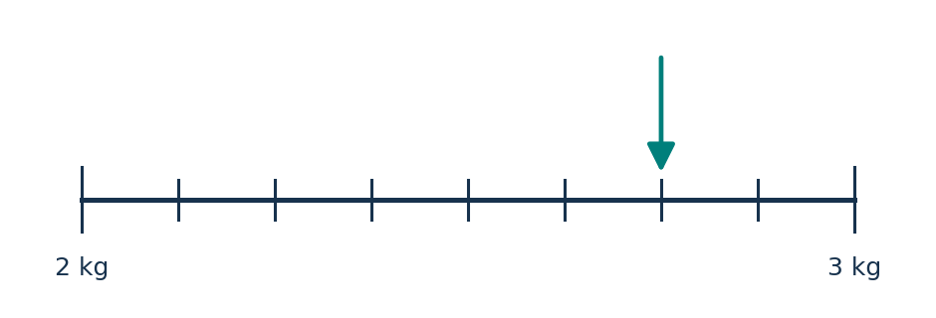  (A) 275 g  (B) 2 075 g  (C) 2 500 g  (D) 2 750 g | Q3C  The arrow shows a mass on the scale. What is the mass in grams?  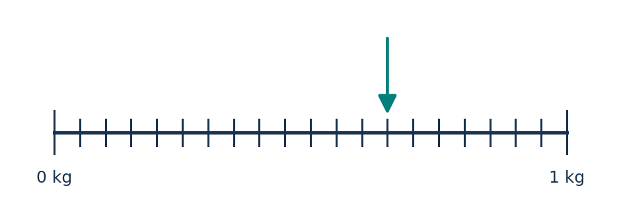  (A) 65 g  (B) 650 g  (C) 605 g  (D) 6 500 g
MASTERY HABIT | Work out the value of each small interval before converting kilograms to grams.

MEASUREMENT | Q30 QUESTION FAMILY
Use a map scale to convert distance to map length • Response style: Choose one answer
A — LEARN THE FORMAT | B — INDEPENDENT MATCH | C — TRANSFER CHECK
Q30A  A map scale is 2 cm : 30 km. What map distance represents 150 km?  (A) 5 cm  (B) 7.5 cm  (C) 10 cm  (D) 15 cm | Q30B  A map scale is 3 cm : 42 km. What map distance represents 196 km?  (A) 7 cm  (B) 10 cm  (C) 12 cm  (D) 14 cm | Q30C  A map scale is 2.5 cm : 40 km. What map distance represents 224 km?  (A) 8.4 cm  (B) 14 cm  (C) 16 cm  (D) 22.4 cm
MASTERY HABIT | Find how many scale groups fit the real distance, then multiply by the map length.

MEASUREMENT | Q31 QUESTION FAMILY
Calculate travel time from distance and average speed • Response style: Write a whole number of hours
A — LEARN THE FORMAT | B — INDEPENDENT MATCH | C — TRANSFER CHECK
Q31A  A car travels 260 km at an average of 70 km each hour. How long does the journey take, to the nearest hour?  Answer: __________________ | Q31B  A bus travels 315 km at an average of 80 km each hour. How long does the journey take, to the nearest hour?  Answer: __________________ | Q31C  A train travels 540 km at an average of 95 km each hour. How long does the journey take, to the nearest hour?  Answer: __________________
MASTERY HABIT | Use time = distance / speed, then round only at the end as instructed.

MEASUREMENT | Q36 QUESTION FAMILY
Multiply a repeated length by the number of lengths • Response style: Choose one answer
A — LEARN THE FORMAT | B — INDEPENDENT MATCH | C — TRANSFER CHECK
Q36A  A swimmer completes 75 lengths of a 25 m pool. How far does the swimmer travel?  (A) 100 m  (B) 1 500 m  (C) 1 875 m  (D) 3 750 m | Q36B  A swimmer completes 64 lengths of a 50 m pool. How far does the swimmer travel?  (A) 1 600 m  (B) 3 200 m  (C) 3 250 m  (D) 6 400 m | Q36C  An athlete completes 120 lengths of a 33 m track section. How far does the athlete travel?  (A) 153 m  (B) 3 300 m  (C) 3 630 m  (D) 3 960 m
MASTERY HABIT | One length is the stated end-to-end distance; multiply it by the number completed.

MEASUREMENT | Q37 QUESTION FAMILY
Find cuboid depth from volume, length and width • Response style: Write the depth in centimetres
A — LEARN THE FORMAT | B — INDEPENDENT MATCH | C — TRANSFER CHECK
Q37A  A rectangular pool is 20 m long and 8 m wide. Its volume is 240 cubic metres. What is its depth in centimetres?  Answer: __________________ | Q37B  A rectangular tank is 25 m long and 10 m wide. Its volume is 500 cubic metres. What is its depth in centimetres?  Answer: __________________ | Q37C  A pool is 32 m long and 12.5 m wide. Its volume is 680 cubic metres. What is its depth in centimetres?  Answer: __________________
MASTERY HABIT | Divide volume by the base area, then convert metres to centimetres.

MEASUREMENT | Q38 QUESTION FAMILY
Find the area of a uniform border around a rectangle • Response style: Choose one answer
A — LEARN THE FORMAT | B — INDEPENDENT MATCH | C — TRANSFER CHECK
Q38A  A 1 m-wide tiled border surrounds a 20 m by 10 m pool. What is the area of the border?  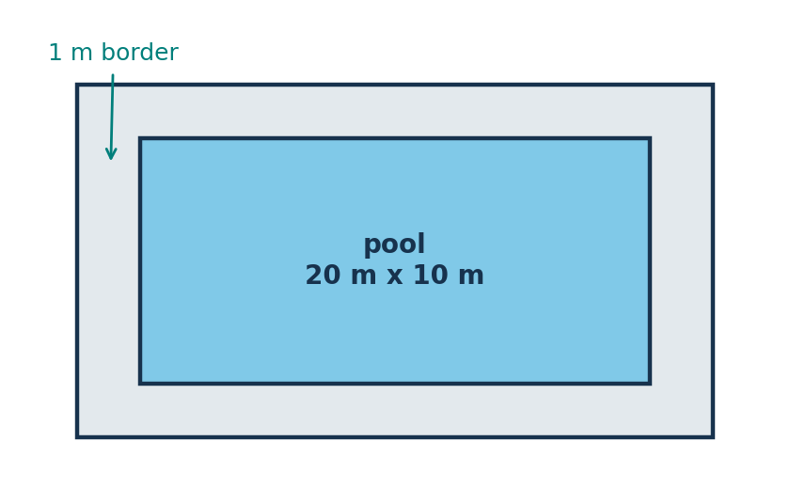  (A) 32 square metres  (B) 64 square metres  (C) 200 square metres  (D) 264 square metres | Q38B  A 1.5 m-wide path surrounds a 25 m by 12 m garden. What is the area of the path?  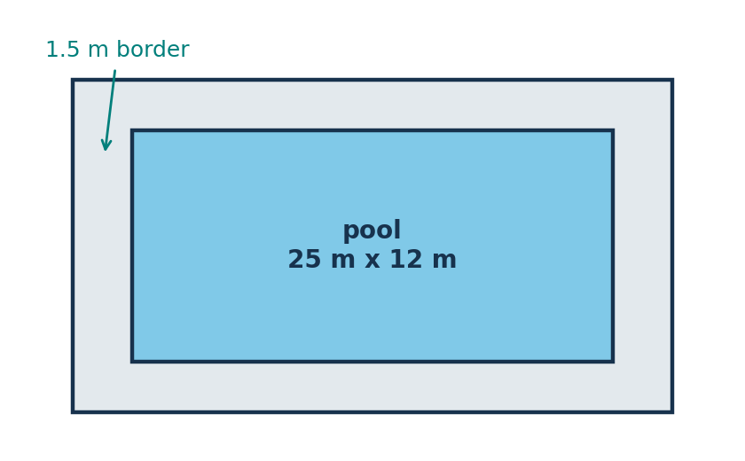  (A) 55.5 square metres  (B) 81 square metres  (C) 120 square metres  (D) 420 square metres | Q38C  A 2 m-wide deck surrounds a 30 m by 15 m pool. What is the area of the deck?  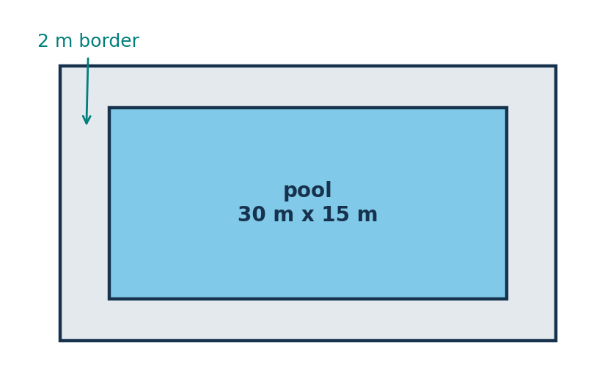  (A) 90 square metres  (B) 180 square metres  (C) 190 square metres  (D) 196 square metres
MASTERY HABIT | Calculate outer area minus inner area; the border is added on both sides of each dimension.

GEOMETRY | Q1 QUESTION FAMILY
Classify a quadrilateral from its shape • Response style: Choose one name
A — LEARN THE FORMAT | B — INDEPENDENT MATCH | C — TRANSFER CHECK
Q1A  What is the name of this shape?  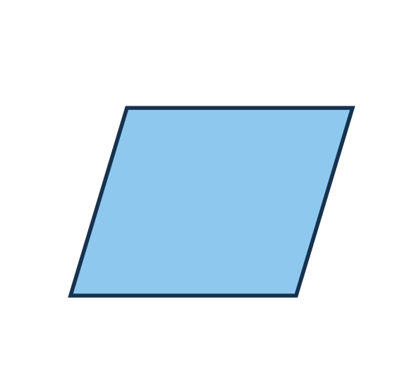  (A) kite  (B) parallelogram  (C) trapezium  (D) rhombus | Q1B  What is the name of this shape?  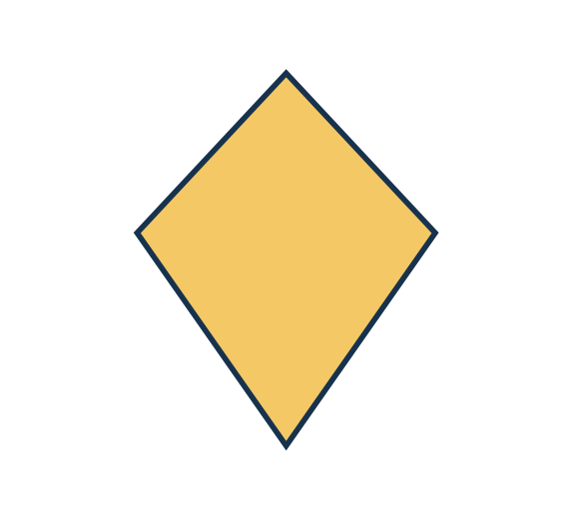  (A) kite  (B) parallelogram  (C) trapezium  (D) rhombus | Q1C  What is the name of this shape?  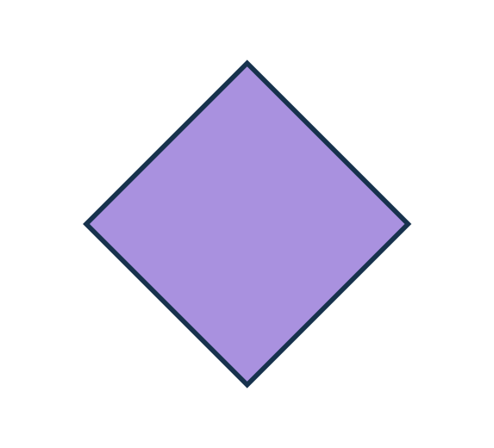  (A) kite  (B) parallelogram  (C) trapezium  (D) rhombus
MASTERY HABIT | Use defining properties, especially pairs of parallel sides and equal adjacent sides.

GEOMETRY | Q5 QUESTION FAMILY
Identify a labelled point from ordered coordinates • Response style: Choose one labelled position
A — LEARN THE FORMAT | B — INDEPENDENT MATCH | C — TRANSFER CHECK
Q5A  Which labelled position is at (-3, 4)?  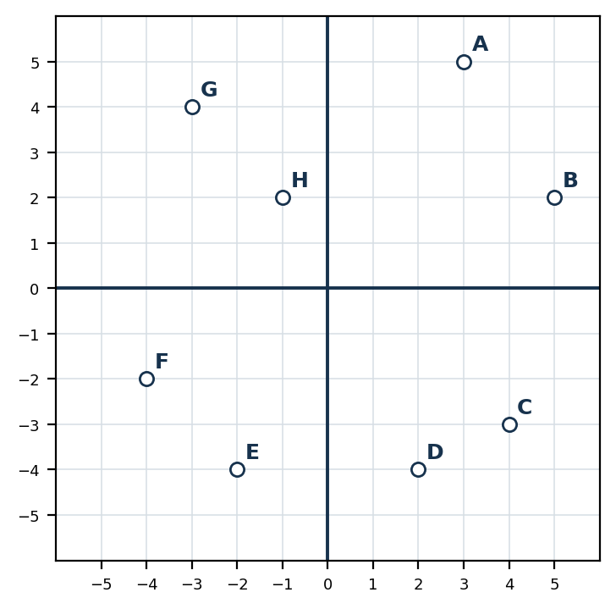  (A) Position A  (B) Position B  (C) Position C  (D) Position D  (E) Position E  (F) Position F  (G) Position G  (H) Position H | Q5B  Which labelled position is at (4, -2)?  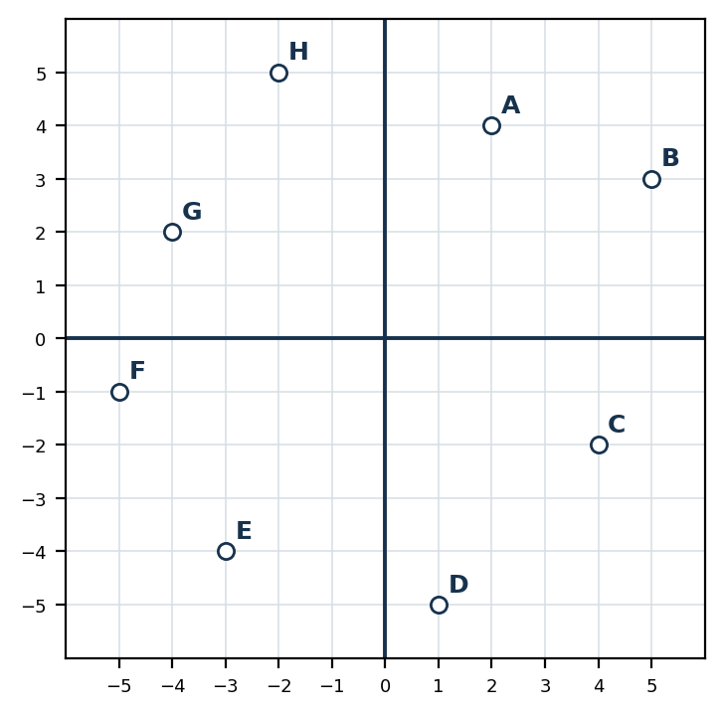  (A) Position A  (B) Position B  (C) Position C  (D) Position D  (E) Position E  (F) Position F  (G) Position G  (H) Position H | Q5C  Which labelled position is at (-2, -5)?  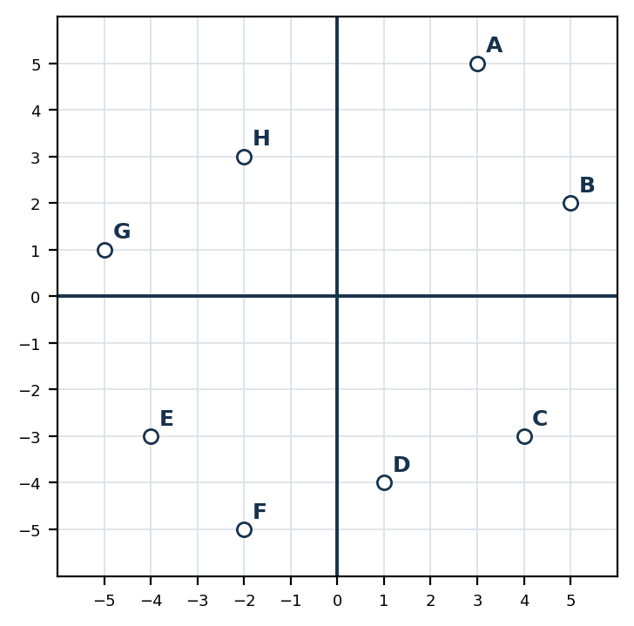  (A) Position A  (B) Position B  (C) Position C  (D) Position D  (E) Position E  (F) Position F  (G) Position G  (H) Position H
MASTERY HABIT | Move along the x-axis first, then vertically using the y-coordinate.

GEOMETRY | Q7 QUESTION FAMILY
Use angle relationships on parallel lines • Response style: Choose one angle
A — LEARN THE FORMAT | B — INDEPENDENT MATCH | C — TRANSFER CHECK
Q7A  Lines PQ and RS are parallel. What is the size of angle A?  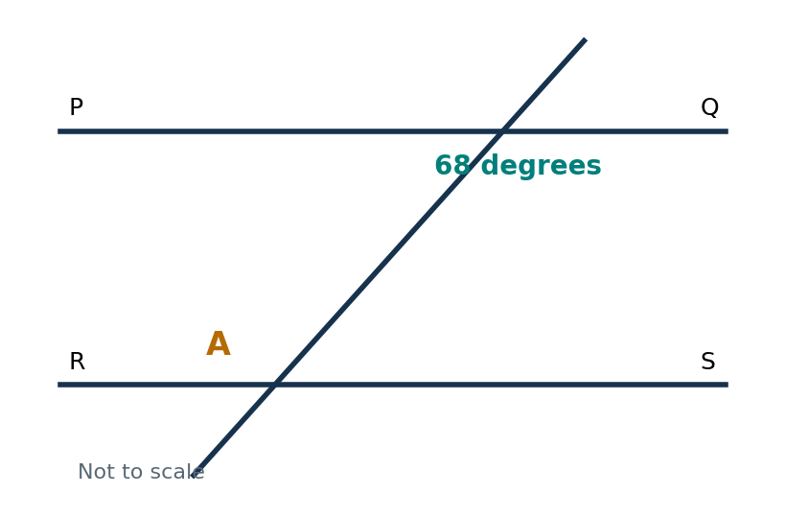  (A) 68 degrees  (B) 90 degrees  (C) 112 degrees  (D) 248 degrees | Q7B  Lines PQ and RS are parallel. What is the size of angle A?  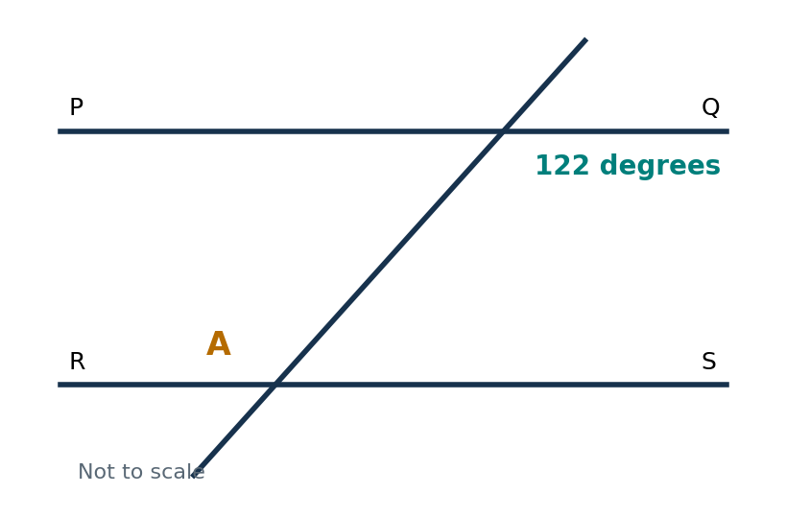  (A) 58 degrees  (B) 122 degrees  (C) 180 degrees  (D) 238 degrees | Q7C  Lines PQ and RS are parallel. What is the size of angle A?  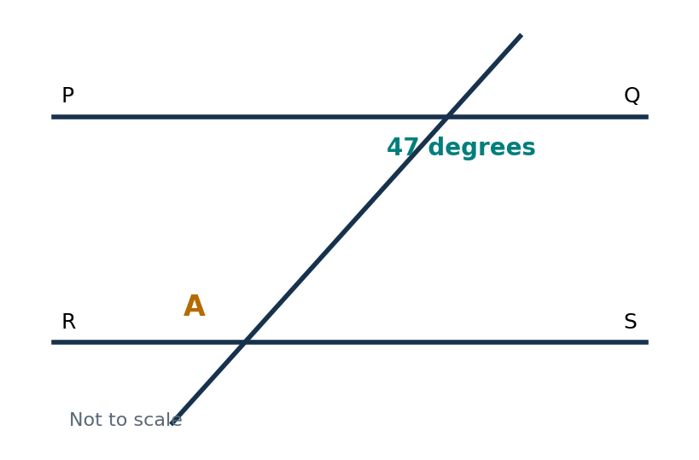  (A) 43 degrees  (B) 47 degrees  (C) 90 degrees  (D) 133 degrees
MASTERY HABIT | Mark corresponding, alternate and co-interior relationships before calculating.

GEOMETRY | Q9 QUESTION FAMILY
Recognise a valid net for a triangular prism • Response style: Choose one diagram
A — LEARN THE FORMAT | B — INDEPENDENT MATCH | C — TRANSFER CHECK
Q9A  Which diagram is a correct net for a triangular prism?  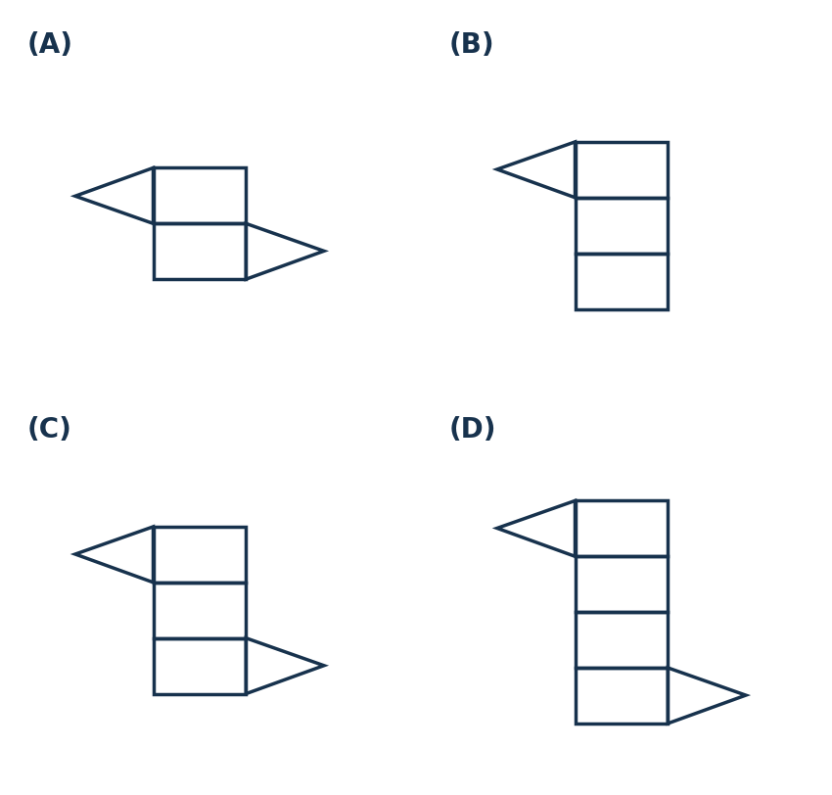  (A) Net A  (B) Net B  (C) Net C  (D) Net D | Q9B  Which diagram is a correct net for a triangular prism?  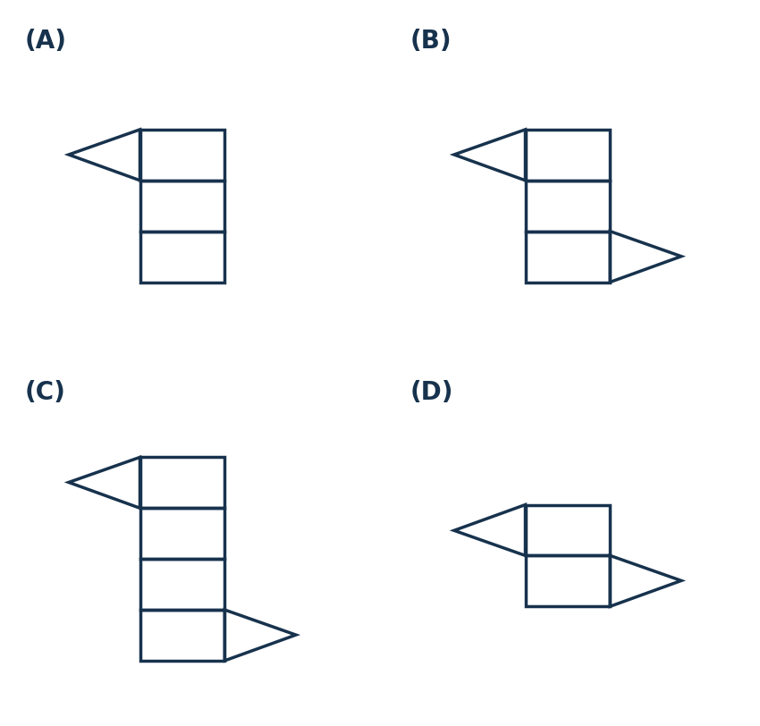  (A) Net A  (B) Net B  (C) Net C  (D) Net D | Q9C  Which diagram is a correct net for a triangular prism?  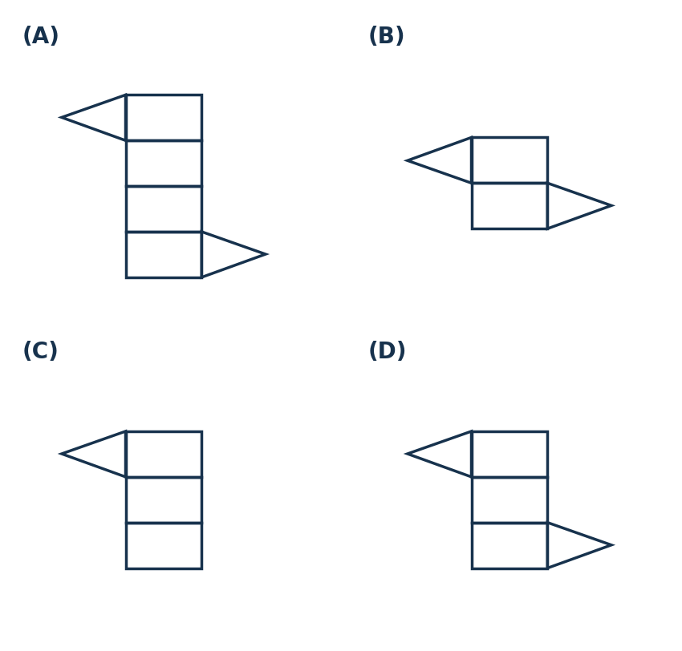  (A) Net A  (B) Net B  (C) Net C  (D) Net D
MASTERY HABIT | A triangular prism net must contain three rectangles and two congruent triangles arranged to fold without overlap.

GEOMETRY | Q12 QUESTION FAMILY
Apply quarter turns to compass directions • Response style: Choose one direction
A — LEARN THE FORMAT | B — INDEPENDENT MATCH | C — TRANSFER CHECK
Q12A  A person faces North East and makes a quarter turn left. Which direction are they facing?  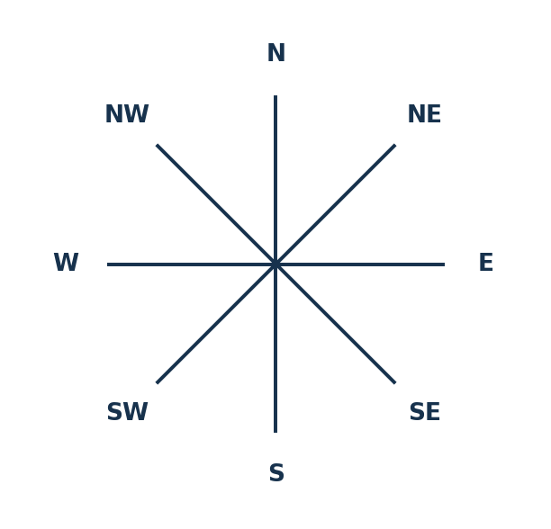  (A) North  (B) East  (C) South East  (D) North West | Q12B  A person faces South West and makes a quarter turn right. Which direction are they facing?  (A) South  (B) South East  (C) North West  (D) North East | Q12C  A person faces West and makes a quarter turn left. Which direction are they facing?  (A) North  (B) South  (C) South East  (D) North West
MASTERY HABIT | A quarter turn on an eight-point compass moves two direction steps.

GEOMETRY | Q33 QUESTION FAMILY
Calculate an interior angle of a regular polygon • Response style: Choose one answer
A — LEARN THE FORMAT | B — INDEPENDENT MATCH | C — TRANSFER CHECK
Q33A  What is the size of each interior angle of a regular hexagon?  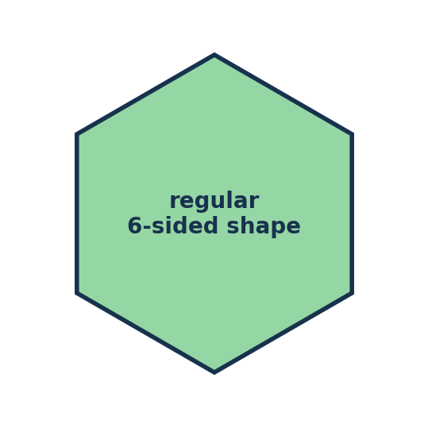  (A) 60 degrees  (B) 120 degrees  (C) 180 degrees  (D) 720 degrees | Q33B  What is the size of each interior angle of a regular octagon?  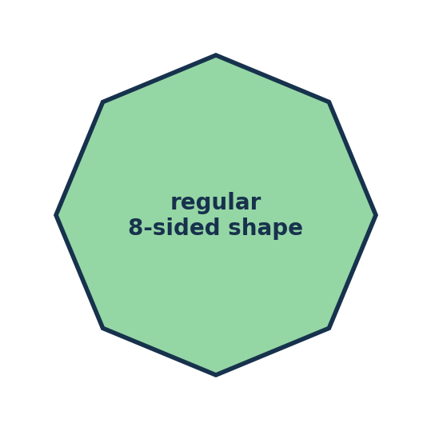  (A) 45 degrees  (B) 108 degrees  (C) 135 degrees  (D) 1 080 degrees | Q33C  What is the size of each interior angle of a regular decagon?  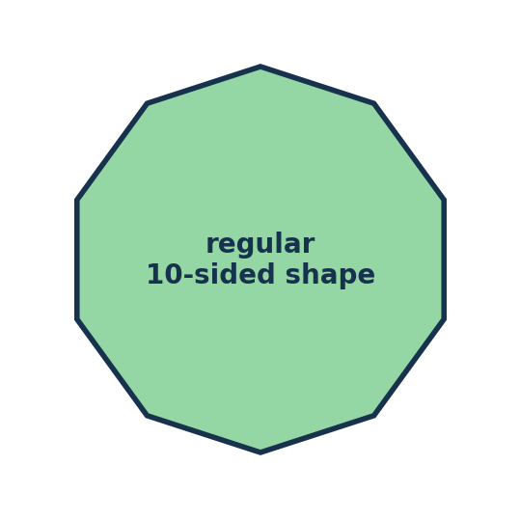  (A) 36 degrees  (B) 72 degrees  (C) 140 degrees  (D) 144 degrees
MASTERY HABIT | Use the interior-angle sum formula, then divide equally among all vertices.

GEOMETRY | Q35 QUESTION FAMILY
Use symmetry in an isosceles trapezium to find a coordinate • Response style: Choose one coordinate pair
A — LEARN THE FORMAT | B — INDEPENDENT MATCH | C — TRANSFER CHECK
Q35A  DEFG is an isosceles trapezium. What are the coordinates of D?  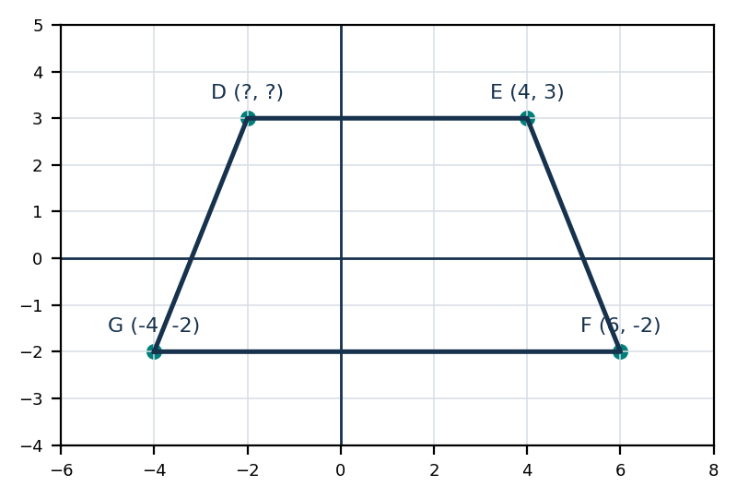  (A) (-2, 3)  (B) (2, 3)  (C) (-4, 3)  (D) (-2, -3) | Q35B  DEFG is an isosceles trapezium. What are the coordinates of D?  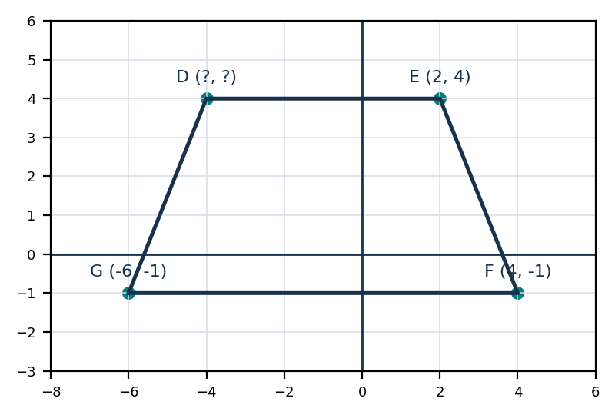  (A) (-6, 4)  (B) (-4, -4)  (C) (-4, 4)  (D) (4, 4) | Q35C  DEFG is an isosceles trapezium. What are the coordinates of D?  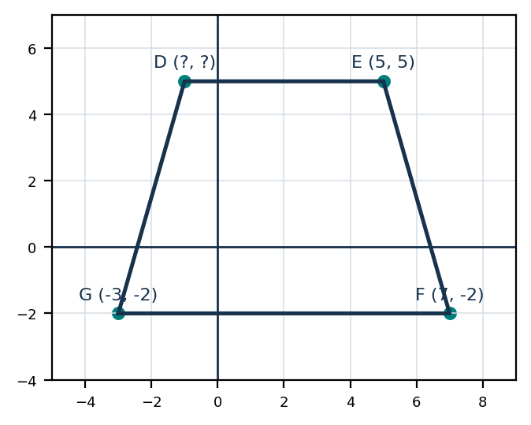  (A) (1, 5)  (B) (-1, 5)  (C) (-3, 5)  (D) (-1, -5)
MASTERY HABIT | Find the vertical line of symmetry from the lower vertices, then reflect the known upper vertex.

STATISTICS & PROBABILITY | Q8 QUESTION FAMILY
Find a theoretical probability from category counts • Response style: Choose one fraction
A — LEARN THE FORMAT | B — INDEPENDENT MATCH | C — TRANSFER CHECK
Q8A  A centre has 4 birds, 10 cats, 8 dogs and 6 rabbits. What is the probability that a rabbit is checked first?  (A) 1/4  (B) 3/11  (C) 3/14  (D) 6/22 | Q8B  A bag has 5 red, 8 blue, 7 yellow and 10 green counters. What is the probability of choosing green?  (A) 1/4  (B) 1/3  (C) 2/5  (D) 1/2 | Q8C  A box has 6 black, 9 red and 3 blue pencils. What is the probability of choosing blue?  (A) 1/3  (B) 1/5  (C) 1/9  (D) 1/6
MASTERY HABIT | Add every category to find the total, then write favourable outcomes over all outcomes.

STATISTICS & PROBABILITY | Q15 QUESTION FAMILY
Identify the modal category from a two-way table • Response style: Choose one category
A — LEARN THE FORMAT | B — INDEPENDENT MATCH | C — TRANSFER CHECK
Q15A  The table shows students in four clubs. Which club is the mode?  (A) Chess  (B) Music  (C) Art  (D) Drama | Q15B  The table shows transport used by two classes. Which type is the mode?  (A) Walk  (B) Bus  (C) Car  (D) Bike | Q15C  The table shows lunch choices in two year groups. Which choice is the mode?  (A) Salad  (B) Pasta  (C) Sandwich  (D) Soup
  Club | Boys | Girls
  Chess | 5 | 7
  Music | 9 | 11
  Art | 13 | 14
  Drama | 8 | 10
  Transport | Class A | Class B
  Walk | 7 | 8
  Bus | 11 | 13
  Car | 9 | 11
  Bike | 5 | 6
  Choice | Year 7 | Year 8
  Salad | 8 | 10
  Pasta | 10 | 12
  Sandwich | 15 | 16
  Soup | 4 | 5
MASTERY HABIT | Combine the two row or column counts for each category before comparing totals.

STATISTICS & PROBABILITY | Q19 QUESTION FAMILY
Interpret grouped frequencies and select a true statement • Response style: Choose one statement
A — LEARN THE FORMAT | B — INDEPENDENT MATCH | C — TRANSFER CHECK
Q19A  The graph shows game scores. Which statement is true?  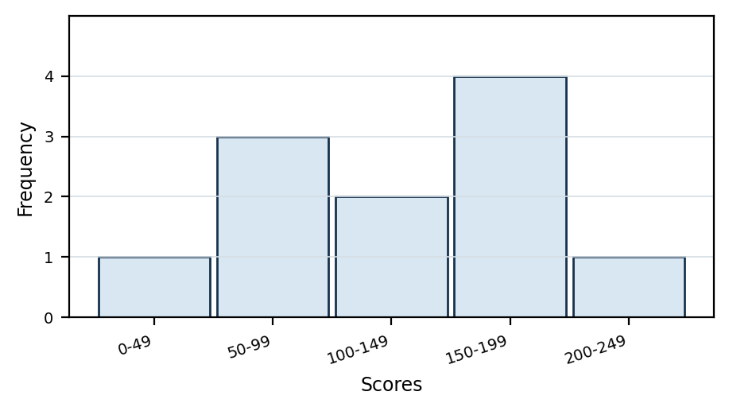  (A) The score was below 100 exactly 4 times.  (B) The score was 100-149 exactly 3 times.  (C) The score was at least 200 exactly 2 times.  (D) The score was 150-199 exactly 2 times. | Q19B  The graph shows game scores. Which statement is true?  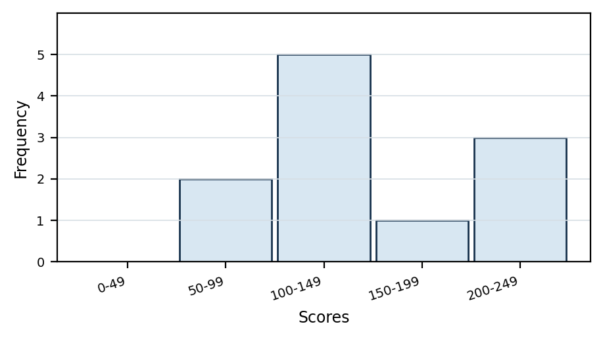  (A) The score was below 100 more than once.  (B) The score was 100-149 exactly 4 times.  (C) The score was below 200 exactly 7 times.  (D) The score was 200-249 most often. | Q19C  The graph shows game scores. Which statement is true?  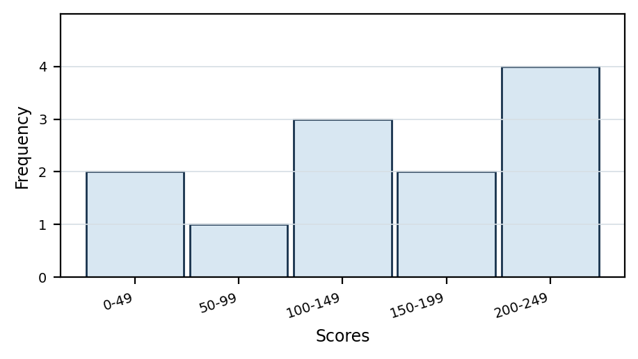  (A) The score was below 100 exactly 2 times.  (B) The score was 100-149 exactly 3 times.  (C) The score was at least 200 exactly 5 times.  (D) The score was 150-199 most often.
MASTERY HABIT | Translate each statement into the bins it includes, then add those frequencies carefully.

STATISTICS & PROBABILITY | Q32 QUESTION FAMILY
Use a percentage to predict a likely count • Response style: Write one numerical answer
A — LEARN THE FORMAT | B — INDEPENDENT MATCH | C — TRANSFER CHECK
Q32A  Seventy percent of the marbles in a bag are blue. If 10 are selected at random, how many are likely to be blue?  Answer: __________________ | Q32B  Thirty-five percent of a set of cards are green. If 20 are selected at random, how many are likely to be green?  Answer: __________________ | Q32C  Forty-five percent of seedlings are native plants. If 40 are selected, how many are likely to be native?  Answer: __________________
MASTERY HABIT | Convert the percentage to a fraction or decimal, then multiply by the sample size.

STATISTICS & PROBABILITY | Q34 QUESTION FAMILY
Find a missing value when the mean is known • Response style: Choose one answer
A — LEARN THE FORMAT | B — INDEPENDENT MATCH | C — TRANSFER CHECK
Q34A  The mean attendance over 5 days is 84. The first four days are 78, 86, 82 and 84. What is day 5?  (A) 84  (B) 86  (C) 90  (D) 94 | Q34B  The mean number of visitors over 6 days is 72. The first five days are 66, 75, 70, 80 and 69. What is day 6?  (A) 70  (B) 72  (C) 74  (D) 78 | Q34C  The mean score over 7 games is 125. The first six scores are 118, 126, 130, 122, 128 and 121. What is game 7?  (A) 125  (B) 126  (C) 128  (D) 130
  Day | 1 | 2 | 3 | 4 | 5
  Attendance | 78 | 86 | 82 | 84 | ?
  Day | 1 | 2 | 3 | 4 | 5 | 6
  Visitors | 66 | 75 | 70 | 80 | 69 | ?
  Game | 1 | 2 | 3 | 4 | 5 | 6 | 7
  Score | 118 | 126 | 130 | 122 | 128 | 121 | ?
MASTERY HABIT | Use mean x number of values to recover the total, then subtract the known values.

STATISTICS & PROBABILITY | Q40 QUESTION FAMILY
Compare ranges from a summary table • Response style: Choose one range
A — LEARN THE FORMAT | B — INDEPENDENT MATCH | C — TRANSFER CHECK
Q40A  Which subject has the greatest range, and what is that range?  (A) Maths, 61  (B) English, 57  (C) Science, 44  (D) Science, 66 | Q40B  Which area has the greatest range, and what is that range?  (A) Reading, 31  (B) Reading, 61  (C) Writing, 56  (D) Inquiry, 54 | Q40C  Which team has the greatest range, and what is that range?  (A) Team A, 58  (B) Team C, 62  (C) Team B, 65  (D) Team B, 85
  Subject | Minimum | Median | Maximum
  Maths | 18 | 48 | 79
  English | 25 | 51 | 82
  Science | 22 | 55 | 88
  Area | Minimum | Median | Maximum
  Reading | 30 | 62 | 91
  Writing | 28 | 58 | 84
  Inquiry | 35 | 60 | 89
  Team | Minimum | Median | Maximum
  Team A | 14 | 40 | 72
  Team B | 20 | 50 | 85
  Team C | 18 | 49 | 80
MASTERY HABIT | For each category, calculate maximum minus minimum; the median is not used for range.

FINANCIAL MATHS | Q22 QUESTION FAMILY
Substitute time into a cost rule with a fixed fee • Response style: Write one dollar amount
A — LEARN THE FORMAT | B — INDEPENDENT MATCH | C — TRANSFER CHECK
Q22A  A designer charges a $150 base fee plus $40 per hour. What is the cost for 12 hours?  Answer: __________________ | Q22B  A technician charges an $85 call-out fee plus $25 per hour. What is the cost for 18 hours?  Answer: __________________ | Q22C  A consultant charges a $240 base fee plus $60 per hour. What is the cost for 9 hours?  Answer: __________________
MASTERY HABIT | Multiply the hourly charge first, then add the base fee once.

FINANCIAL MATHS | Q23 QUESTION FAMILY
Match a fixed-fee cost rule to its graph • Response style: Choose one labelled line
A — LEARN THE FORMAT | B — INDEPENDENT MATCH | C — TRANSFER CHECK
Q23A  Hiring equipment costs $100 plus $30 per hour. Which line shows the cost?  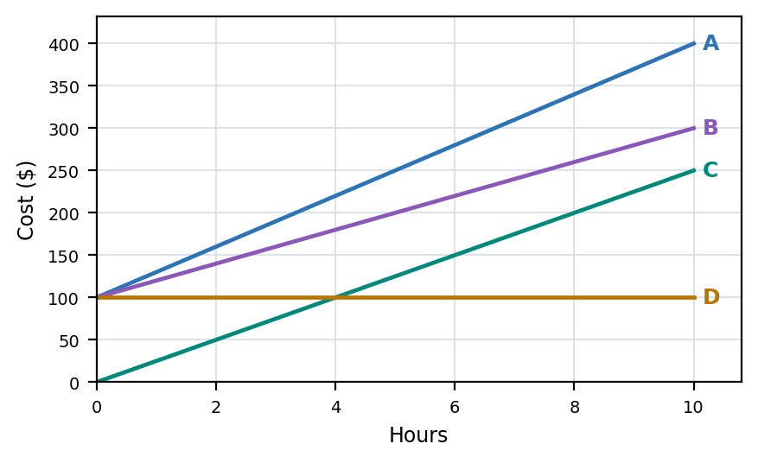  (A) Line A  (B) Line B  (C) Line C  (D) Line D | Q23B  A service costs $200 plus $25 per hour. Which line shows the cost?  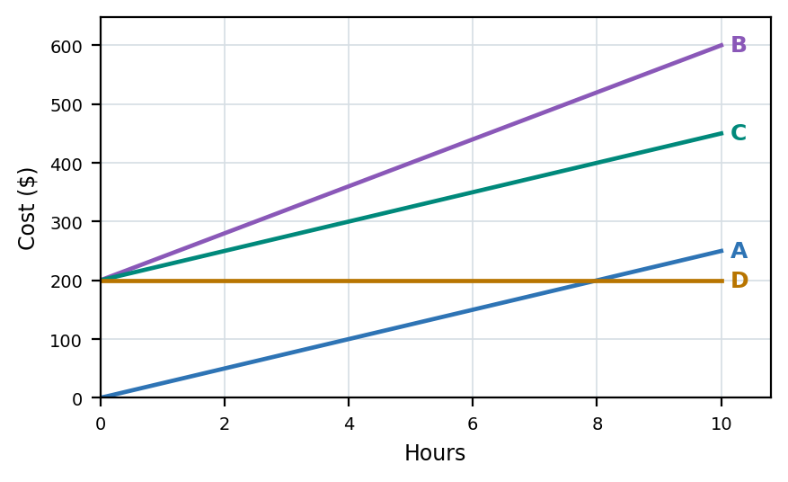  (A) Line A  (B) Line B  (C) Line C  (D) Line D | Q23C  A tutor charges $50 plus $45 per hour. Which line shows the cost?  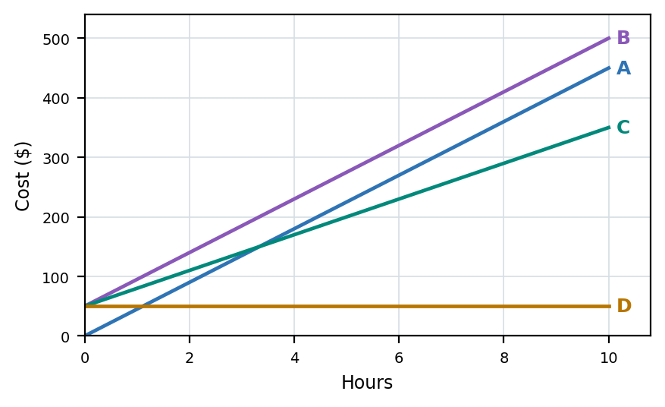  (A) Line A  (B) Line B  (C) Line C  (D) Line D
MASTERY HABIT | The y-intercept is the fixed fee and the slope is the hourly charge.

FINANCIAL MATHS | Q24 QUESTION FAMILY
Apply a percentage discount to both parts of a cost rule • Response style: Choose the discounted rule
A — LEARN THE FORMAT | B — INDEPENDENT MATCH | C — TRANSFER CHECK
Q24A  A service costs a $160 base fee plus $40 per hour. A 20% discount applies. Which is the discounted cost?  (A) $128 plus $40 per hour  (B) $128 plus $32 per hour  (C) $140 plus $32 per hour  (D) $140 plus $36 per hour | Q24B  A technician charges $120 plus $50 per hour. A 10% discount applies. Which is the discounted cost?  (A) $110 plus $40 per hour  (B) $108 plus $50 per hour  (C) $108 plus $45 per hour  (D) $110 plus $45 per hour | Q24C  A consultant charges $200 plus $36 per hour. A 25% discount applies. Which is the discounted cost?  (A) $175 plus $27 per hour  (B) $150 plus $36 per hour  (C) $175 plus $30 per hour  (D) $150 plus $27 per hour
MASTERY HABIT | If the discount applies to the whole service, reduce both the fixed fee and the hourly rate.

FINANCIAL MATHS | Q39 QUESTION FAMILY
Use rate and gross income to find hours worked • Response style: Write one numerical answer
A — LEARN THE FORMAT | B — INDEPENDENT MATCH | C — TRANSFER CHECK
Q39A  The table shows pay information. How many hours did Hana work?  Answer: __________________ | Q39B  The table shows pay information. How many hours did Wiremu work?  Answer: __________________ | Q39C  The table shows pay information. How many hours did Mele work?  Answer: __________________
  Name | Rate | Income before deductions | Deductions
  Hana | $24.50 | $441.00 | $66.15
  Matiu | $27.00 | $540.00 | $81.00
  Name | Rate | Income before deductions | Deductions
  Wiremu | $27.20 | $598.40 | $101.73
  Leah | $26.00 | $520.00 | $88.40
  Name | Rate | Income before deductions | Deductions
  Mele | $31.50 | $787.50 | $133.88
  Aria | $29.00 | $638.00 | $108.46
MASTERY HABIT | Use hours = income before deductions / hourly rate; deductions are irrelevant to this question.

TEACHER ANSWER GUIDE
Answers by question family • 1 of 3
SMART | Skill focus | A answer | B answer | C answer
Q4 | Divide a five-digit whole number by a one-digit number | 2 457 | 2 898 | 4 284
Q6 | Identify prime numbers from a mixed list | A, C and D | A, C and D | A, C and D
Q11 | Apply order of operations, including powers | B - 34 | C - 17 | D - 32
Q13 | Round decimals to a stated place value | C - 47.29 | B - 125.9 | D - 8.995
Q14 | Express a number as a product of prime factors | B - 2 x 3^2 | C - 2^3 x 5 | D - 2^2 x 3 x 7
Q16 | Compare decimal multiplication and division results with 1 | A and C | B and D | A and B
Q18 | Check multiplication statements involving fractions | A and B | A and B | A and C
Q21 | Use factors, multiples and square numbers together | B - 36 | B - 100 | C - 196
Q25 | Add fractions with unlike denominators | C - 11/12 km | D - 23/24 km | B - 13/10 m
Q26 | Use the lowest common multiple in repeating-time contexts | C - 10:40 | B - 1:33 pm | D - 09:20
Q27 | Recover a whole amount from the fraction remaining | C - 400 | B - 630 | D - 600
Q28 | Find one part of a total divided in a ratio | D - 1 000 mL | C - 175 | B - 600 g
Q29 | Find a fraction of a journey distance | B - 90 km | C - 150 km | D - 315 km
Q10 | Simplify an expression by collecting like terms | B - 6a + 2b | C - 4m + 3n | D - 3x - 3y

TEACHER ANSWER GUIDE
Answers by question family • 2 of 3
SMART | Skill focus | A answer | B answer | C answer
Q17 | Translate a multi-step comparison into an algebraic expression | D - 2(n - 4) | C - 3(p + 7) | B - 4(t - 6)
Q20 | Substitute into a formula containing brackets and division | C - 54 | B - 45 | D - 75
Q2 | Find the difference between positive and negative temperatures | C - 13 degrees C | B - 11 degrees C | D - 15 degrees C
Q3 | Read a mass scale and convert kilograms to grams | C - 1 400 g | D - 2 750 g | B - 650 g
Q30 | Use a map scale to convert distance to map length | C - 10 cm | D - 14 cm | B - 14 cm
Q31 | Calculate travel time from distance and average speed | 4 hours | 4 hours | 6 hours
Q36 | Multiply a repeated length by the number of lengths | C - 1 875 m | B - 3 200 m | D - 3 960 m
Q37 | Find cuboid depth from volume, length and width | 150 cm | 200 cm | 170 cm
Q38 | Find the area of a uniform border around a rectangle | B - 64 square metres | C - 120 square metres | D - 196 square metres
Q1 | Classify a quadrilateral from its shape | B - parallelogram | A - kite | D - rhombus
Q5 | Identify a labelled point from ordered coordinates | G | C | F
Q7 | Use angle relationships on parallel lines | C - 112 degrees | B - 122 degrees | D - 133 degrees
Q9 | Recognise a valid net for a triangular prism | C | B | D

TEACHER ANSWER GUIDE
Answers by question family • 3 of 3
SMART | Skill focus | A answer | B answer | C answer
Q12 | Apply quarter turns to compass directions | D - North West | C - North West | B - South
Q33 | Calculate an interior angle of a regular polygon | B - 120 degrees | C - 135 degrees | D - 144 degrees
Q35 | Use symmetry in an isosceles trapezium to find a coordinate | A - (-2, 3) | C - (-4, 4) | B - (-1, 5)
Q8 | Find a theoretical probability from category counts | C - 3/14 | B - 1/3 | D - 1/6
Q15 | Identify the modal category from a two-way table | C - Art | B - Bus | C - Sandwich
Q19 | Interpret grouped frequencies and select a true statement | A | A | B
Q32 | Use a percentage to predict a likely count | 7 | 7 | 18
Q34 | Find a missing value when the mean is known | C - 90 | B - 72 | D - 130
Q40 | Compare ranges from a summary table | D - Science, 66 | B - Reading, 61 | C - Team B, 65
Q22 | Substitute time into a cost rule with a fixed fee | $630 | $535 | $780
Q23 | Match a fixed-fee cost rule to its graph | A | C | B
Q24 | Apply a percentage discount to both parts of a cost rule | B - $128 base fee plus $32 per hour | C - $108 base fee plus $45 per hour | D - $150 base fee plus $27 per hour
Q39 | Use rate and gross income to find hours worked | 18 hours | 22 hours | 25 hours

